

**28 June 2021**

**RAMpiler+ ®**

**06/07nm SP Compiler**

***User Manual***

***Revision 1.0***

**User Manual**

**RAMpiler+ ®**

**06/07nm SP Compiler**

**Revision 1.0**

**28 June 2021**

# TABLE OF CONTENTS

TABLE OF CONTENTS 2

LIST OF FIGURES 3

LIST OF TABLES 4

REVISION HISTORY 5

1. Introduction 6

2. Compiler Usage 6

2.1. SRAM Options 6

2.2. Main GUI Pull Down Menus 7

2.3. GUI Options 13

3. RAMpiler+ Pin Definition and Truth Table for Single Port 67

4. RAMpiler+ Naming Convention 70

5. Command Line Syntax 72

6. Ip-tagging for the GDS 75

7. READ/WRITE Timing Diagram Without Output Register 76

8. READ/WRITE Timing Diagram With Output Register 77

9. Dolphin Technology Redundancy Architecture 78

10. Dolphin Technology Row Redundancy Architecture 82

11. Dolphin Technology Fuse Architecture 84

12. Dolphin Technology Fault Verilog Modeling 84

13. Error Correction Codes (ECC) 86

Appendix A: Datasheet description 88

Appendix B: Optimizing for AREA 93

Appendix C: Optimizing for Timing 96

Appendix D: LefGraphic 99

Appendix E: Read Write Margin Settings 101

Appendix F: Dolphin Technology Power Architecture 102

# LIST OF FIGURES

Figure 1. Scan chain and output registers 23

Figure 2. Asynchronous write through diagram 25

Figure 3. Bist mux structure 27

Figure 4. XOR implementation 29

Figure 5. Synchronous write through timing diagram 53

Figure 6. Time for entering/exiting low power mode 58

Figure 7. Time for entering/exiting low power mode when last command is reading 61

Figure 8. Time for entering/exiting low power mode when last command is writing 62

Figure 9. Read/ Write Timing Diagram without Registered Output 76

Figure 10. Read/ Write Timing Diagram with Registered Output 77

Figure 11. Dolphin Technology 8Kx32 cm16 Memory With Row/Column Redundancy 79

Figure 12. Physical Map and Bit Map of the 8k x 32 Block 81

Figure 13. Fuse Box and the Repair Mechanism 82

Figure 14. Fuse Box for the Redundant Row. 84

Figure 15. Visual Representation of Data File Given to Fault Verilog 85

Figure 16. 00ff Maps to 8 Address and 8 Data Bits as Shown 85

Figure 17. 00ff Maps to 6 Address and 10 Data Bits When Data Bits Not a Multiple of 4 85

Figure 18. 2401 Mapping to 10 Address and 4 Data Bits 86

Figure 19. Dolphin Technology Memory Block Structure 103

Figure 20. Dolphin Technology’s Power Strap Scheme 103

Figure 21. Tiling Memory Blocks 106

# LIST OF TABLES

Table 1. RAMpiler Single Port Pin Definition 67

Table 2. Single Port Truth Table 67

Table 3. Naming Convention for Top Level 70

Table 4. Timing diagram parameter description 77

Table 5. Fuse Box Column Bit Map of the 8K x 32 80

Table 6. SRAM Logical and Physical Characteristics 82

# REVISION HISTORY

|  |  |  |  |  |
| --- | --- | --- | --- | --- |
| Revision | Date | Description of Changes | Compiler | Author |
| 1.0 | 06/28/2021 | Initial document |  | Viet |

# Introduction

This document explains each option available in the memory compiler. The next sections explain the options and the ranges for Single Port. The user also has the option of selecting two redundant quad-rows, two redundant Columns (IO’s) or both for the Single Port. The compiler is capable of generating the fuse box logic as well if the user wishes to use the redundancy feature. The compiler comes complete with tool tips for ease of use and is capable of providing suggestions for the most optimal configuration based on input criteria specified by the user.

# Compiler Usage

## SRAM Options

### Basic options

DTI supports these following basic options. Customer can see more details in part 2.2

* Column mux option
* Output drive strength
* Write enable
* register output (with and without scanning mode)
* Asynchronous write through
* Clock edge
* Test input
* XOR
* Column redundancy
* Row redundancy
* Output enable
* Decap
* Deep Nwell
* VT options
* Memory cell options
* Synchronous write

### Additional options

DTI supports some additional options as well. Additional/extra license is required for them.

* Low power
* Low leakage
* Power gating
* Dual power
* Isolation

## Main GUI Pull Down Menus

### File

The **“File”** option shown below is a pull down menu. The user **must** select **“New”** to generate a new instance of a memory. After generating the required instances, the user can select **“Quit”** to quit the tool.

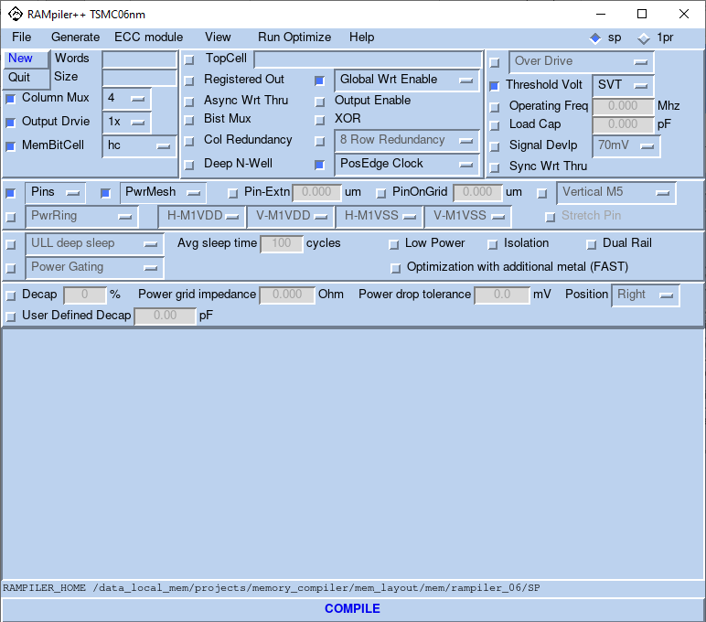

### Generate

The **“Generate”** option allows the user to select the different views that can be generated. By default the compiler generates all the views. If the user wants to generate only timing views, he/she can deselect the **“ALL”** button. Timing views are always generated. If the aim is to find out the optimum configuration, the user can generate the timing views only. Based on the access time and the area from the datasheet, the user can decide to generate other views. The different views available in the compiler are **Netlist, Gds, Lef, Verilog, ATPG, MBIST, Logic Vision** and **Timing**. The user can generate all the views for a memory instance in less than a minute. Depending on the requirements, different views are added to the compiler from time to time. The compiler also generates the **“Antenna Lef”**.

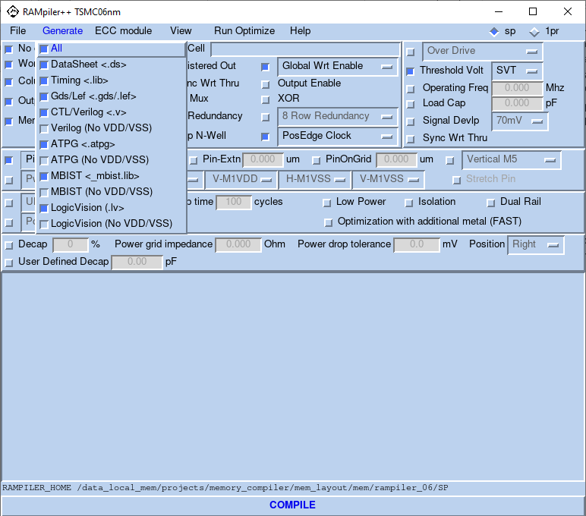

### View

The **“View”** menu shown below allows the user to look at different views available in the memory compiler. When the user selects an option, it is opened in a File browser as a separate window. The **“LEFGRAPHIC”** option is a graphic version of the LEF. This helps the user to look at the pin positions and orientations. The user also has an option to select the metals that need to be shown in the graphic.

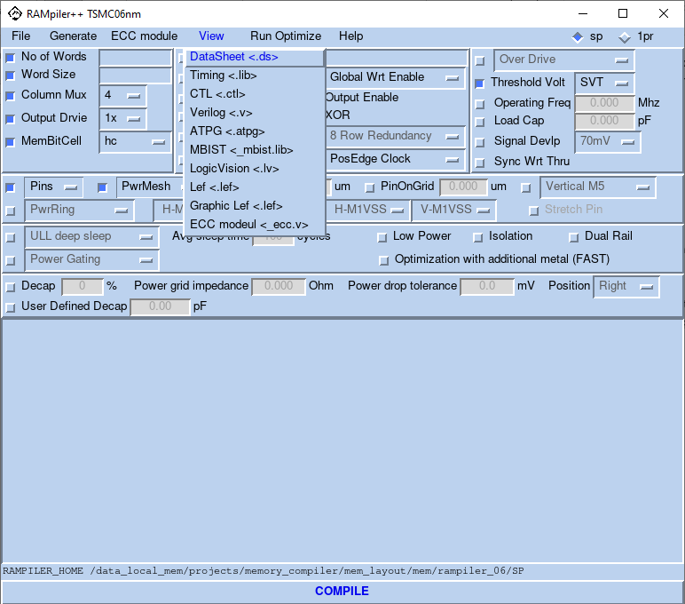

### Optimize

The “Run Optimize” option allows the user to generate an instance with the required configuration while optimizing for “Area”, “Speed” or “Power”. When the optimize option is selected and the number of words and word size are entered, the compiler automatically selects the appropriate column mux option that gives the optimal configuration for that logical size per the criteria entered. Finally, the user always has the option to override the configuration provided by the compiler if needed. Using this feature significantly slows down the compiler. To avoid this penalty, expert users are recommended to turn off this option by selecting “None”.

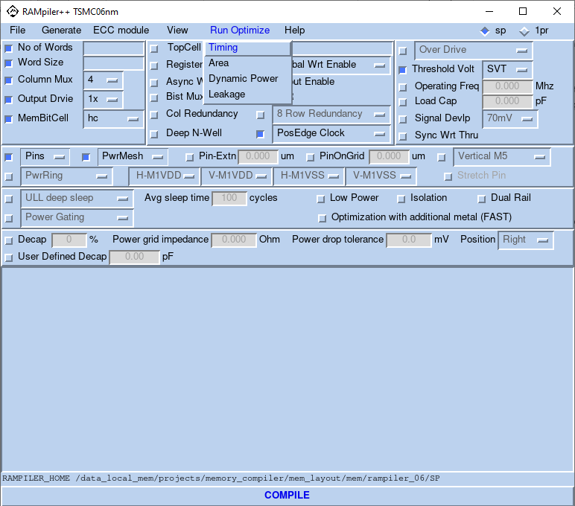

### Help

The “Help” option enables the user to view this document and also provides information regarding the version number of the current memory compiler.

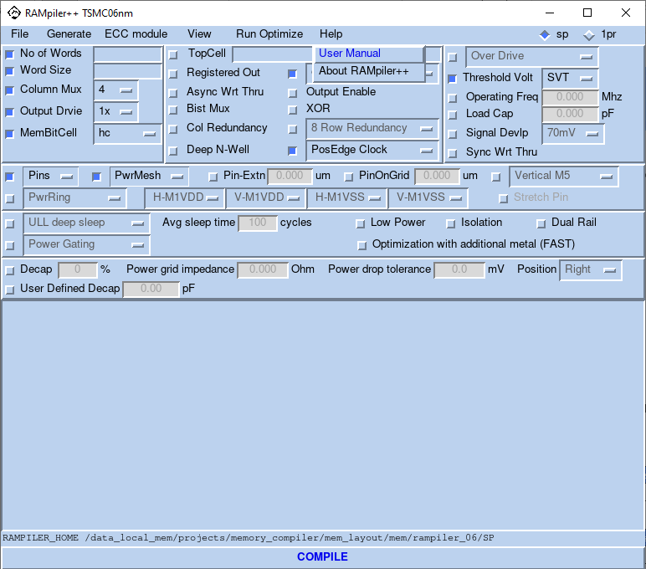

## GUI Options

### Number of Words

The number of words (Depth) determines the number of rows and can be specified using **“No of Words”** option.

Number of physical rows = No. of words/Column Mux.

**Note:** Column Mux is also a number specified by the user and will be discussed later in this document.

|  |  |
| --- | --- |
| Compiler Type | Maximum Physical Rows |
| SinglePort | 256 |

|  |  |
| --- | --- |
| Compiler Type | Minimum Physical Rows |
| SinglePort | 1 |

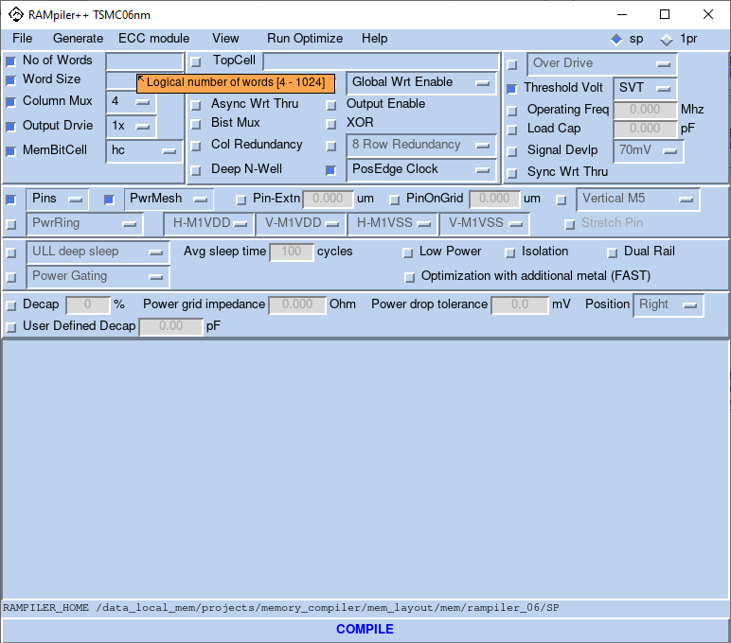

### Word Size

Word Size (Width) determines the number of columns and can be specified using **“Word Size”** option.

Number of physical columns = Word Size*Column Mux

**Note:** Column Mux is also a number specified by the user and will be discussed later in this document.

|  |  |
| --- | --- |
| Compiler Type | Physical Columns Range |
| SinglePort | 2*column mux ~ 1280 |

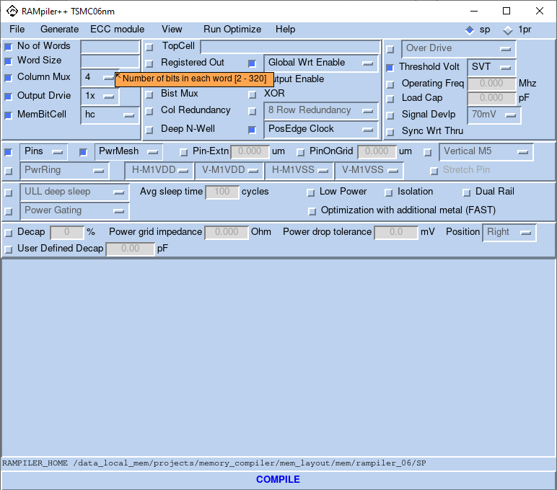

### Top Cell

Based on the configuration and the options chosen, the compiler will assign a default name. The default name will have the key words that will show the options used in generating the specific block. User can also use his own name while generating the blocks. It can be changed by editing the value in the “**TopCell**” field.

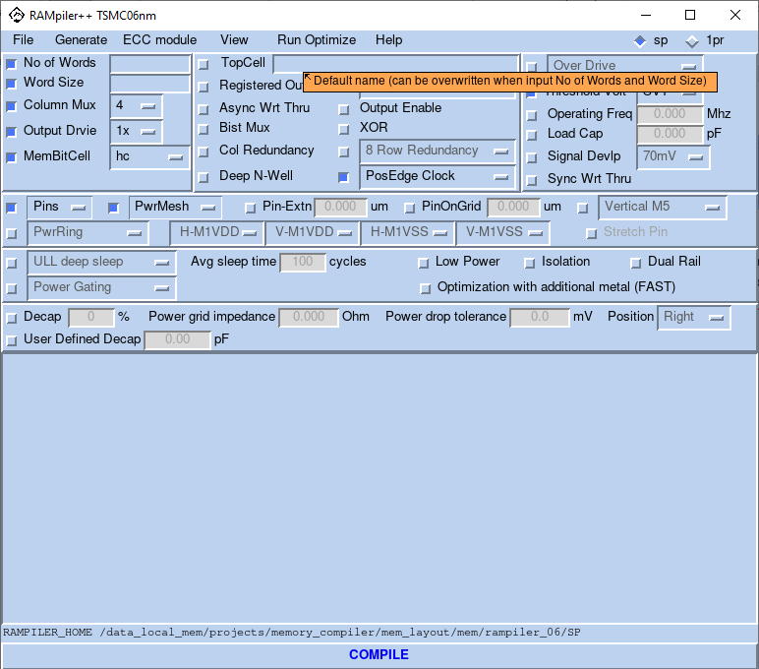

### Operating Frequency

The “**Operating Freq**” field value specifies the frequency of operation for the memory instance generated by the memory compiler. It determines the width of the power ring. The power values reported in the data sheet are also dependent on the frequency of operation. There is no other change in the generated memory block. If the frequency of operation is not specified, the reported value in the datasheet will be the worst corner operating frequency.

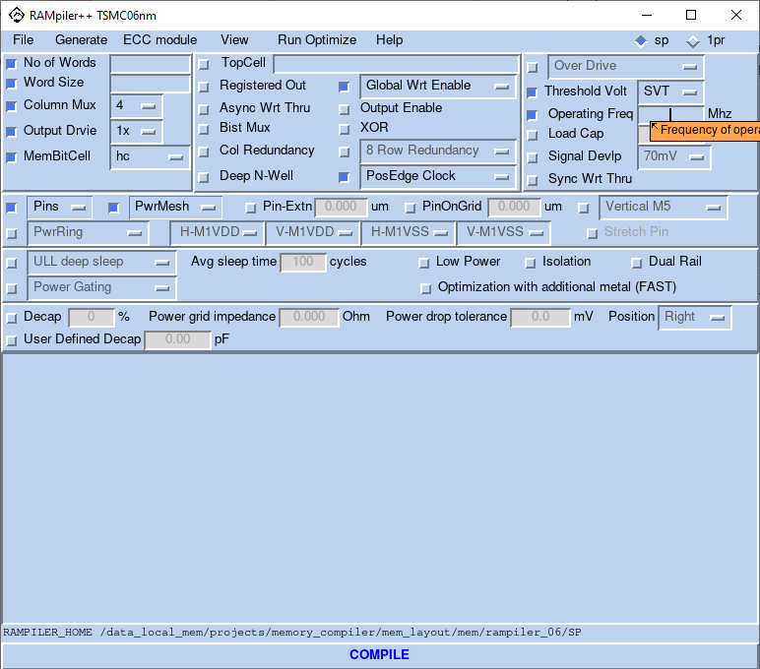

### Over Drive

The user can specify if he wishes to generate the instance using “Over Drive” models. That is, if the operating voltage will be that of over drive allowed by the given technology. For example, for ff+ the ff+_OD operating voltage will be 1.0V + 5%/-15%.

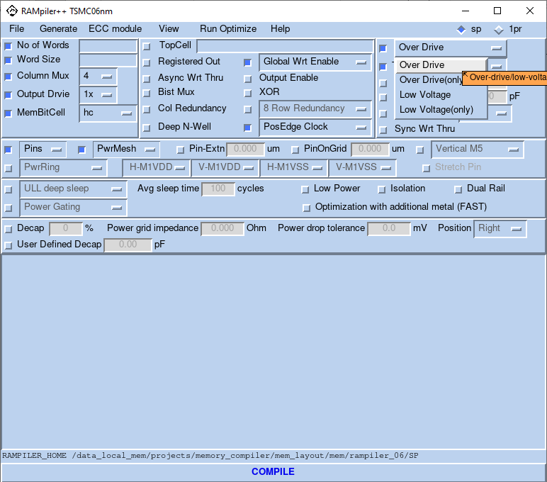

### Output Capacitance Load

The user can specify the load capacitance on the output pin with the help of the **“Load Cap”** option. This is to allow the customers to select the load on the output pins based on their design. By default, the unit is specified in “pF”.

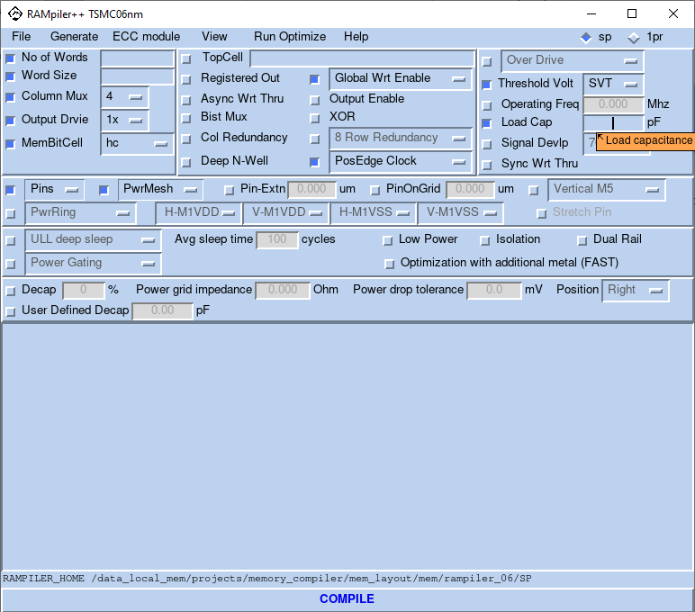

### Different Voltage Threshold

The user has the option to create the instance using a standard Threshold Voltage-SVT, a higher Threshold Voltage-HVT, a lower Threshold Voltage-LVT and an ultra-lower Threshold Voltage-ULVT.

Thus, the peripheral circuitry will be generated with selected layer and the reported timing will be based on the selected Threshold Voltage, too.

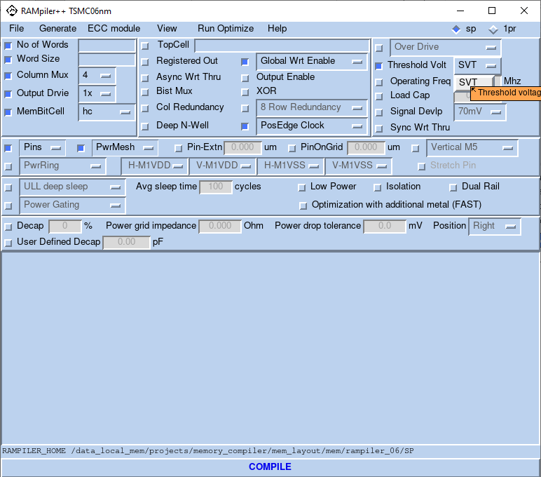

### Column Mux Options

The user can select the column mux to change the aspect ratio of the memory with the help of the drop down menu for **“Column Mux”**. This option can be used to configure the memory instance to provide best area, power and delay figures. A more elaborate explanation can be found in the Appendix section of this document. Following Table summarizes the column mux options allowed for each compiler. Please note that the max depth/width of each compiler MUST be observed while generating each block as well as discussed in section 2.2.1 and 2.2.2 above.

|  |  |
| --- | --- |
| Compiler Type | Column Mux Options |
| SinglePort | 4, 8, 16, 32 |

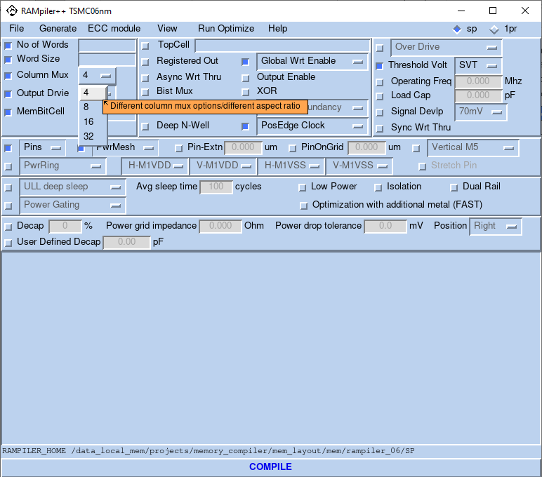

### Output Drive Strength

The user can select the driver sizes optimized to drive 0.1pf(1x) load, 0.25pf(3x) load or 1pf(9x) load using the drop-down menu for **“Output Drive”**. To keep the power low, the user might use the weaker output driver. The larger the driver, the higher the load on the DO but will add to the active power due to larger devices used.

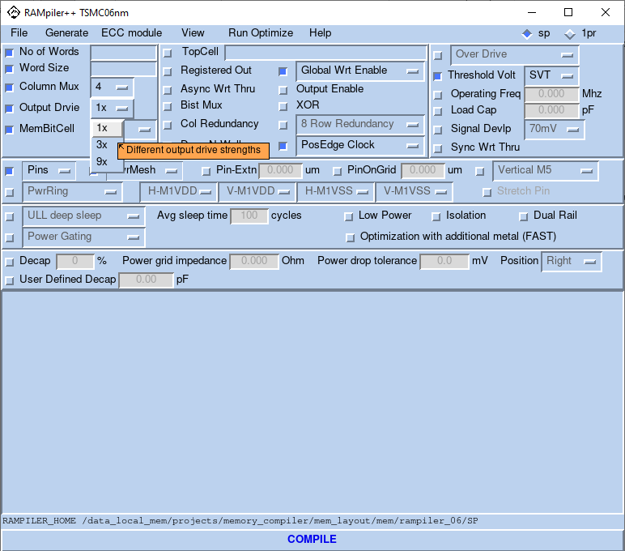

### Write Enable Options

The user can select the write enable options by using the drop-down menu for “**Wrt Enable**”. The options included are Global Write, Bit Write and Byte Write based on their application.

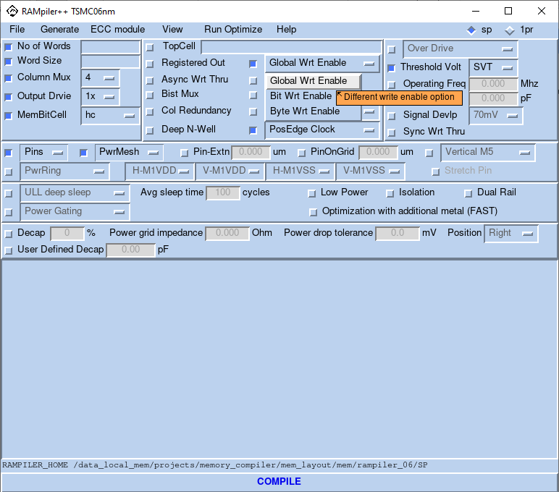

### Registered Outputs/Pipelined

The user can select if he/she wants the output to be registered with the help of **“Registered Out”** check button. That is, if the data is pipelined and will be available in the subsequent cycle. This option also results in smaller access time but there are two cycles. If the customer does not select this option, the access time and cycle time reported in the datasheet are the same. Selecting the Registered Option will result in the two being different based on the block configuration and access time being lower while the cycle time will be more.

* Scan feature: with memory which has output register, Dolphin supports to do the scan testing by three ports SE, SI and SO. Depend on width of DO e.g. N bits, user can setup enable SE = 1, apply a sequential N bits test pattern into SI, then wait N + 1 cycles to start compare the shift out test pattern at SO within next N cycles. With column redundant memory, length of scan chain from SI to SO will be N+2.



Figure 1. Scan chain and output registers

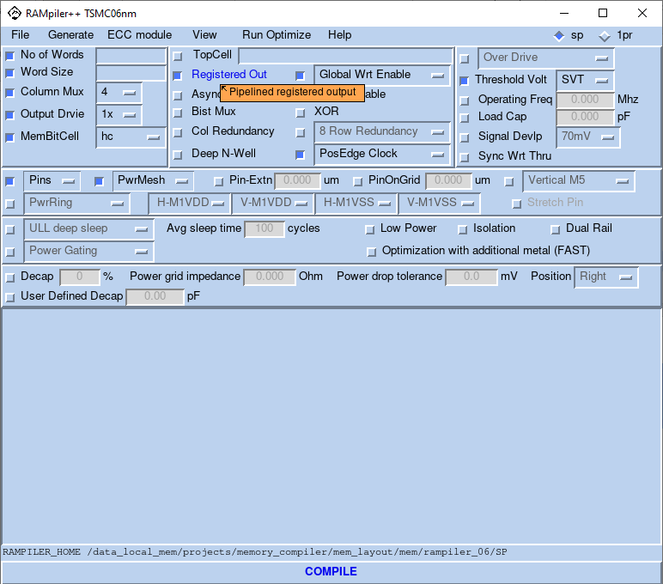

### Asynchronous Write Through

The user can select **“Async Wrt Thru”** option. When this option is selected, the compiler generates an asynchronous write through pin. By setting this input to ‘0’, the user can bypass the memory cells. Din follows the Dout. This is for testing the path from the Input to output with bypassing the memory cell.



Figure 2. Asynchronous write through diagram

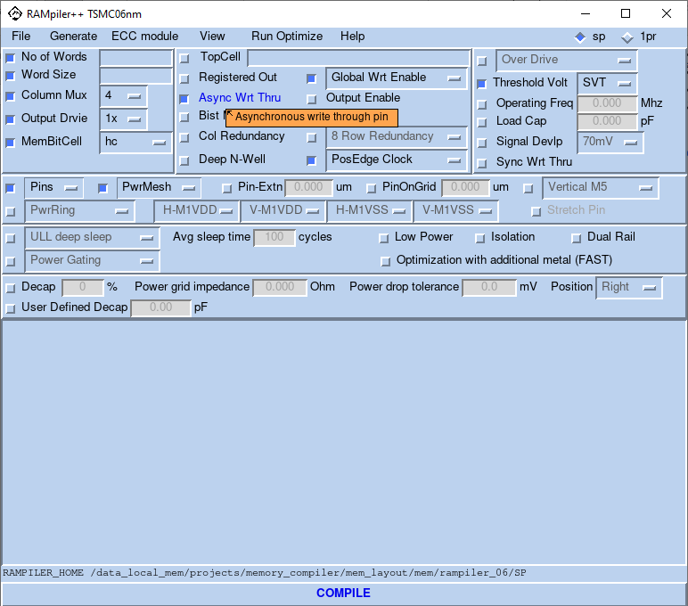

### Clock Edge

Dolphin memories are self-timed and need a clock edge to access memory and generate the internal clock off of. This option is to select which edge of the clock the customer intends to use in accessing the memories, positive or negative. The user can define which edge of the clock is used using the “**Clock Edge**” field.

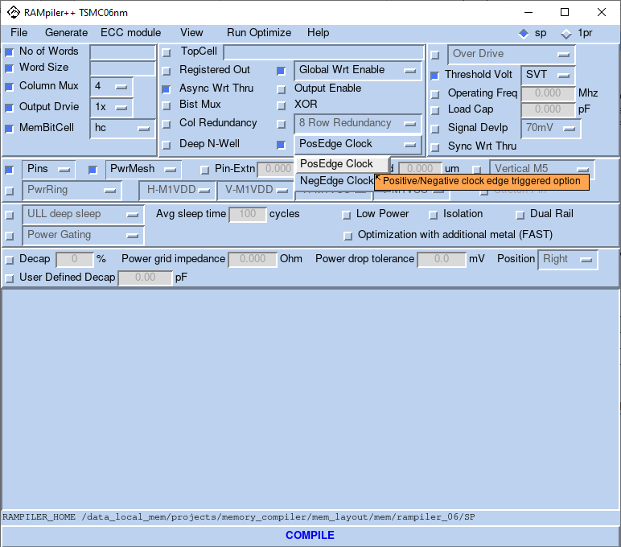

### Test Inputs

The user can select if he/she wants the test pins with the help of **“BistMux”** check button. By selecting this option, input pins will have the test port associated with them. This option enables the user to select between the original Inputs or the test ports. . Figure 3 is showing how it is implemented.



Figure 3. Bist mux structure

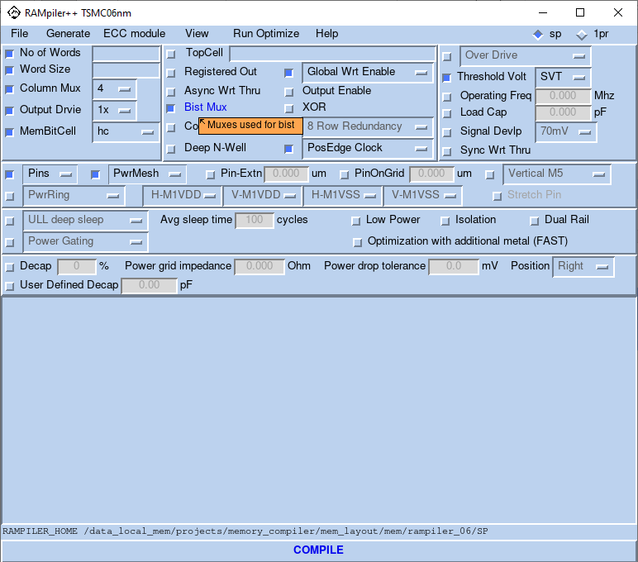

### XOR

By selecting the “XOR” option, the user can choose to XOR the output of the Bist Muxes. The user can XOR the following pins

1. Address, Output Enable, Global Write Enable and Chip Select
2. Address, Output Enable, Global Write Enable, Chip Select and Bit Write Enables

The user must set all the bits apart from the bit being tested to “0” and then generate an input pulse on the pin being tested to see a pulse at the output of the XOR.



Figure 4. XOR implementation

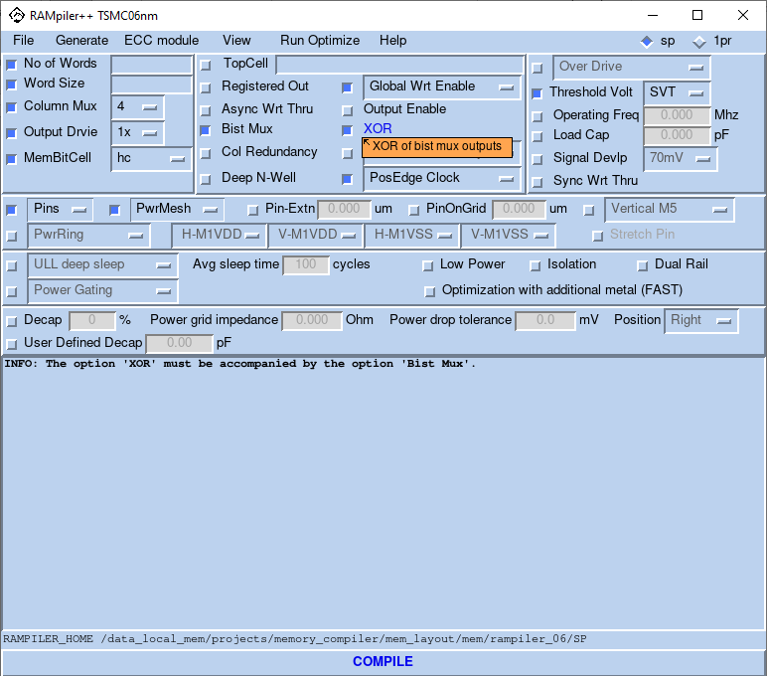

### Pins

The user can select the metal (METAL1, METAL2, METAL3 or ALL) for the input /output pins with the help of the drop-down menu for **“Pins”**. As customers may need to have the ports to the memory instance in different/all metals available, they can select using this option.

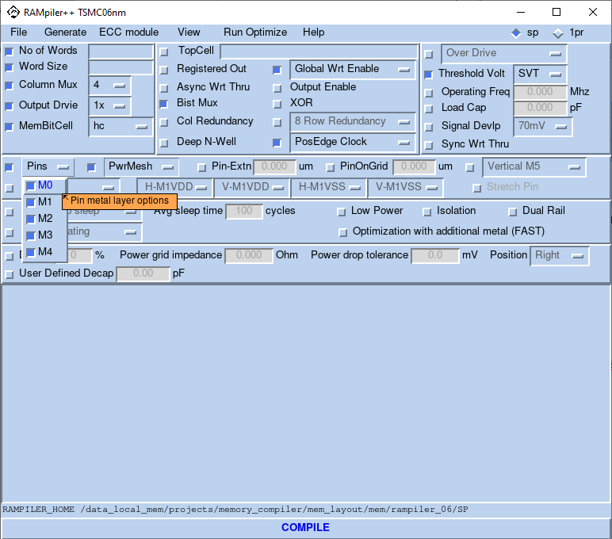

### Pin On Grid

The user can select the pitch for the pins on the grid using the **PinOnGrid** field. The entered value must be 0 or 0.14. That is, customers will select the physical pitch on the memory ports by using this option to meet their metal pitch. Ports will be shifted to the right based on the entered value.

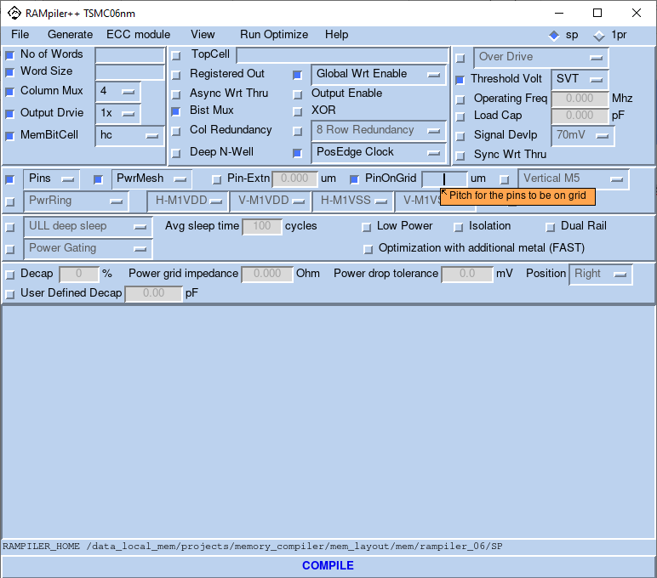

### Pin Extension

The user can select to extend the pins if needed by specifying a value in the **Pin-Extn** field. The entered value must be in 0.005 (manufacturing grid).

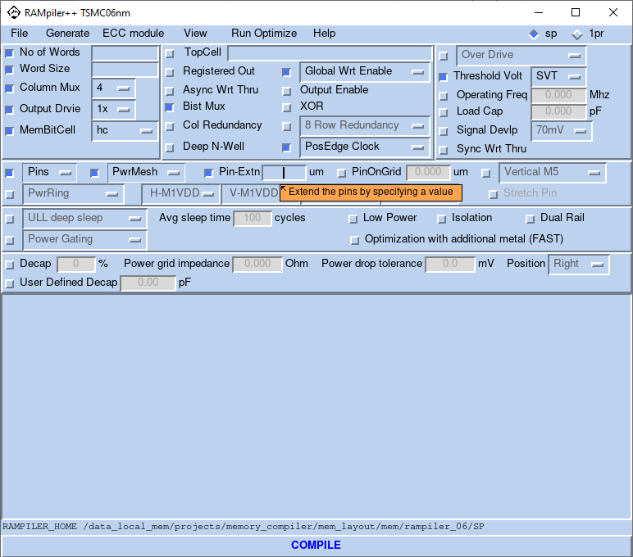

### Power Mesh

Dolphin memory blocks are designed to be tapped from above as the user preferred choice (power ring is an option but not preferred). The blocks use up to M4 which is for power and shielding the array from higher metals. The options in the “**PowerMesh**” field can be used to derive the power from the provided metal configurations on the block edge on top of the Vertical M4 that is the standard mesh. Users can select any combination of metal for the power pins for the given memory instance. Then, power to the memory instance is supplied by proper connections to the M4 power mesh plus the power pins using higher metals.

The options available are

* “M4-V”
* “M4-V, M1”
* “M4-V, M2”
* “M4-V, M3”
* “M4-V, M1, M2”
* “M4-V, M1, M3”
* “M4-V, M2, M3”
* “M4-V, M1, M2, M3”

NOTE: Only if the Fuse Top Metal is selected as M6 Thick 2, can the Power Mesh use the M5 Thick option.

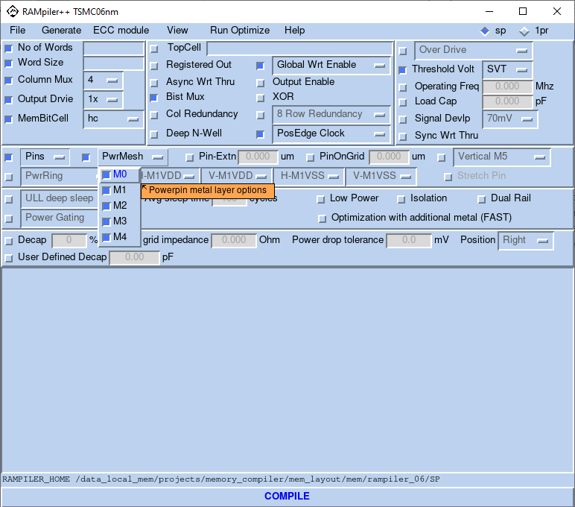

### Metal 5 Option

In addition to the standard M4 power grid, user can select M5 as an option. The orientation of Metal5 for the power mesh can be selected to be Vertical or Horizontal or No Metal5 at all. This is a user optional choice but selecting M5 horizontal will create a two dimensional M4 Vertical/M5 Horizontal power grid with optimum via-4 pilers. Then, the user will tap to this mesh from above as suggested in the power hook up section.

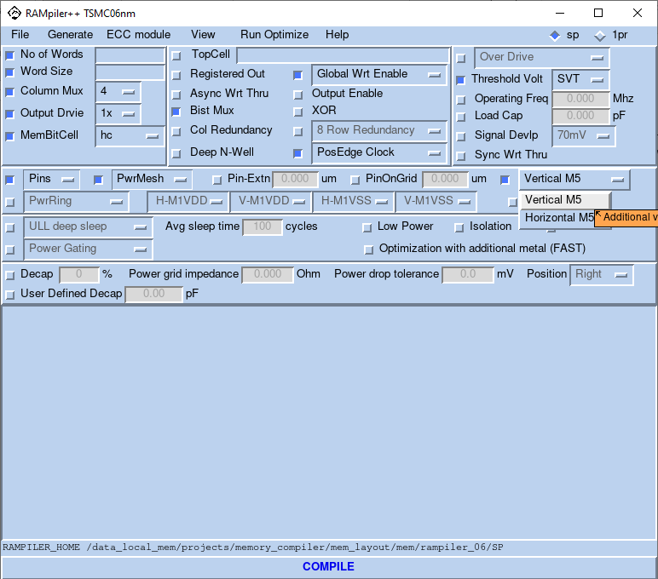

### Power Ring

The user can select the power ring option with the help of **“PwrRing”** drop-down menu. The compiler creates the power ring for VDD and VSS and hooks it up to the internal power pins. The width of the power ring is dependent on the configuration and frequency. We recommend power mesh over the use of power ring as this option will add unnecessary area to the memory blocks.

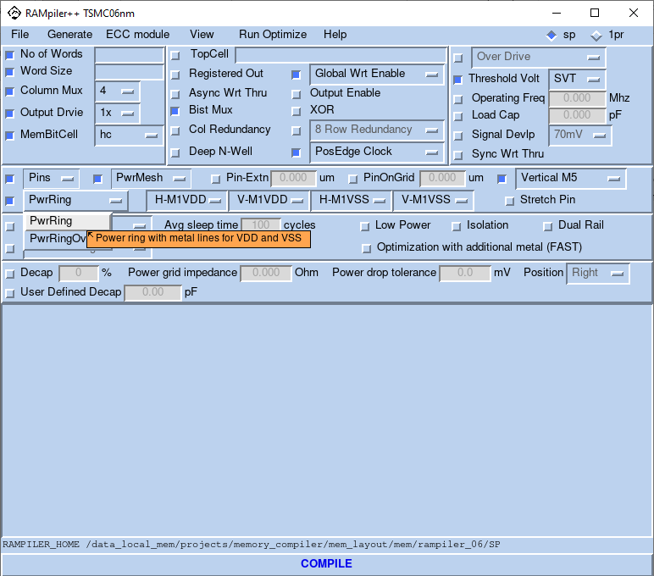

### Power Ring Overlap

The user can select whether he/she wants a power ring with overlapped metal lines for VDD and VSS or non-overlapped metal line for VDD and VSS by selecting **“PwrRingOvlp”** from **“PwrRing”** drop-down menu.

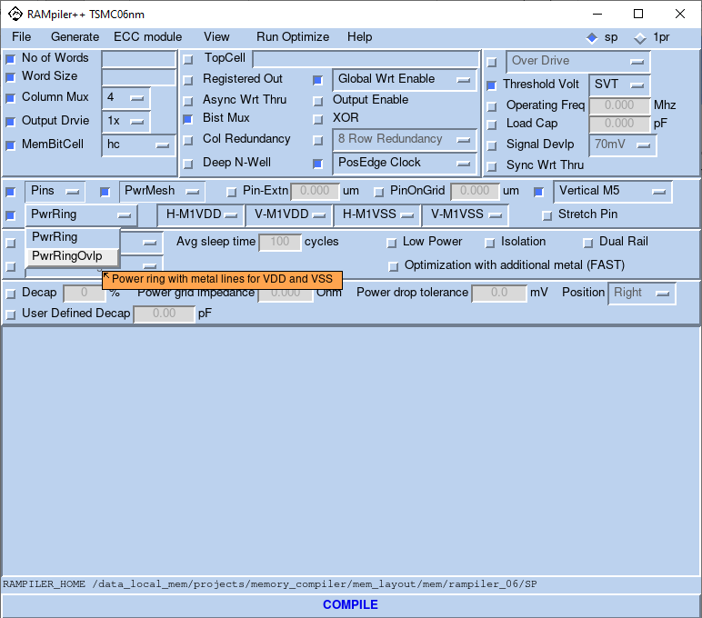

### Stretch Pins

The user can select if he/she wants to stretch the pins to the edge of the Deep N-Well or Power Ring. This option can be selected for blocks that utilize either the Deep N Well or the power ring with the help of **“Stretch Pin”** check button.

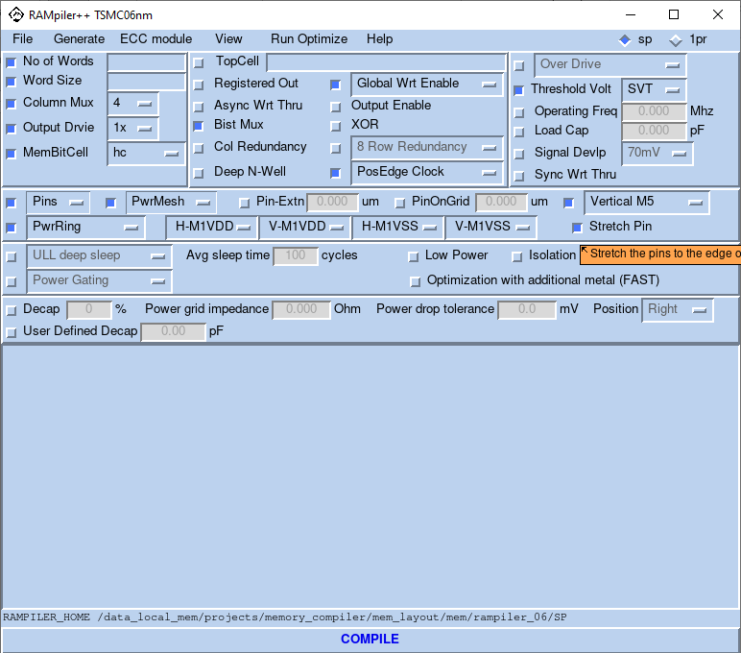

### Horizontal VDD (Used in Conjunction With Power Ring Option)

The user can select the metal (METAL1, METAL2, METAL3 or METAL4) for left and right VDD when the power ring option is selected using **“H-MxVDD”** option.

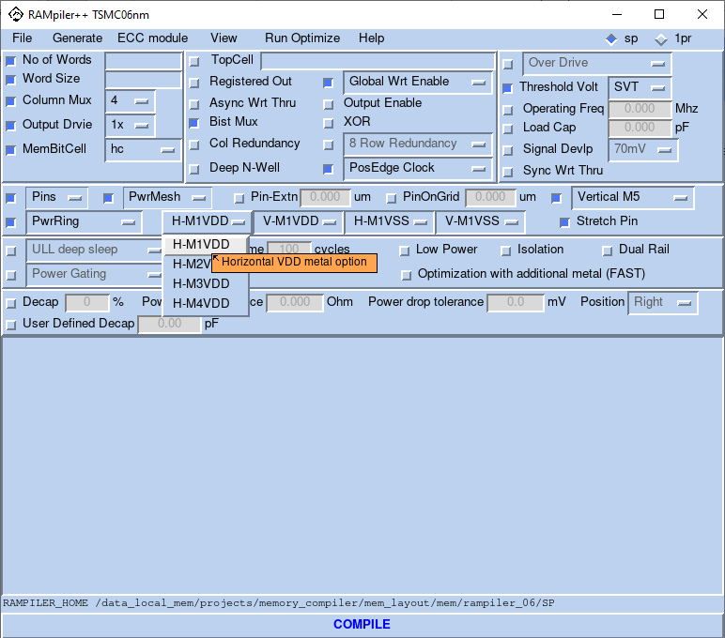

### Horizontal VSS (Used in Conjunction With Power Ring Option)

The user can select the metal (METAL1, METAL2, METAL3 or METAL4) for left and right VSS when the power ring option is selected using **“H-MxVSS”** option.

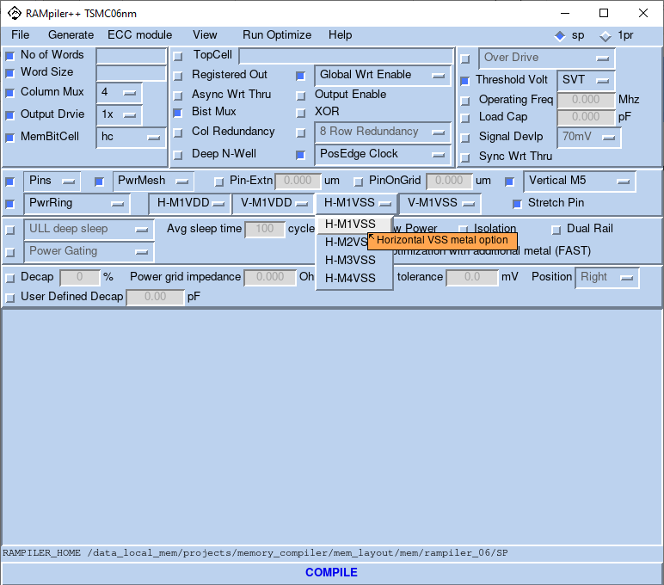

### Vertical VDD (Used in Conjunction With Power Ring Option)

The user can select the metal (METAL1, METAL2, METAL3 or METAL4) for top and bottom VDD when the power ring option is selected using **“V-MxVDD”** option.

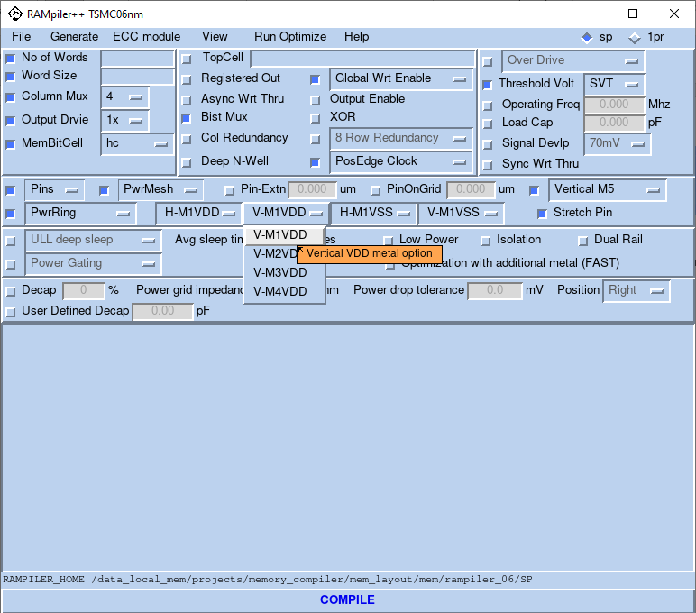

### Vertical VSS (Used in Conjunction With Power Ring Option)

The user can select the metal (METAL1, METAL2, METAL3, METAL4) for top and bottom VSS when the power ring option is selected using **“V-MxVSS”** option.

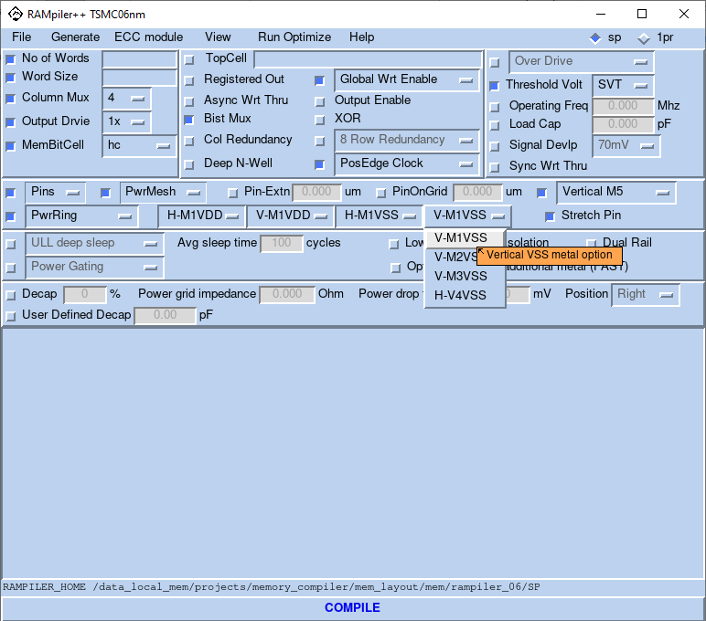

### Row Redundancy

The user can select to add one or a pair of quad redundant rows to the memory block, which consists of four physical rows to replace four adjacent rows (i.e. rows 0, 1, 2 and 3; 4, 5, 6, and 7; …) using **“Row Redundancy”** check button. By selecting “1” the user chooses to add 4 rows (1quad row) while selecting “2” will result in addition of 8 rows (2 quad rows). If this option is not used, 0, the memory block will not have any redundant rows added. The redundant rows are physically placed in the bottom of the memory array.

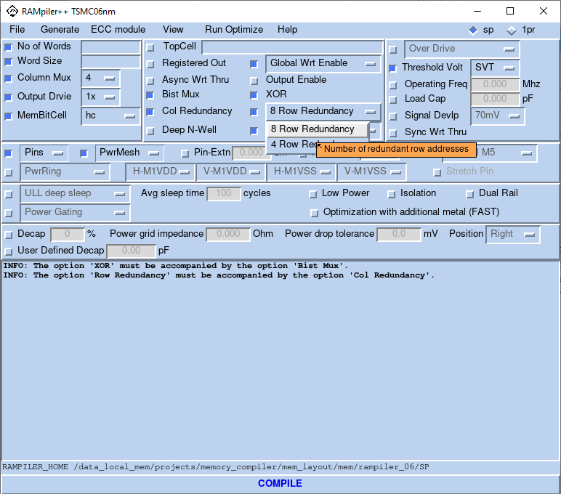

### Column Redundancy

The user can select to have two redundant columns/IOs, one for each half plane of the memory using **“Col Redundancy”** check button. Thus, each half of the block can be repaired with the extra column/IO independently. This is on top of the row redundancy described above, thus creating two dimensional redundancy capabilities for users. Each compiler is capable of creating blocks with no redundancy, row redundancy, column redundancy, and both row and column redundancy.

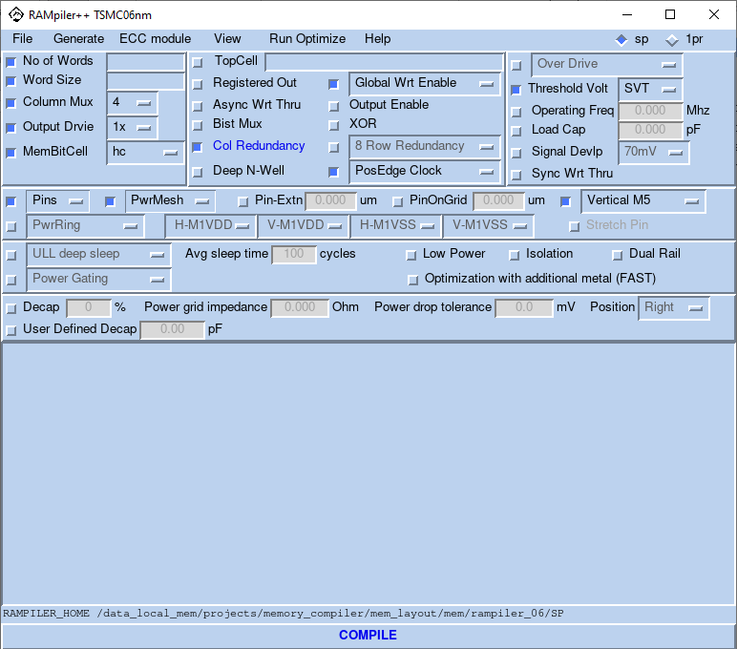

### Mentor M Bist Models

The “**MentorMBistModels**” option gives the user the option to select a Mentor Bist Model to interface with the memory instance. Selecting this option will generate the wrapper RTL for the compiled block.

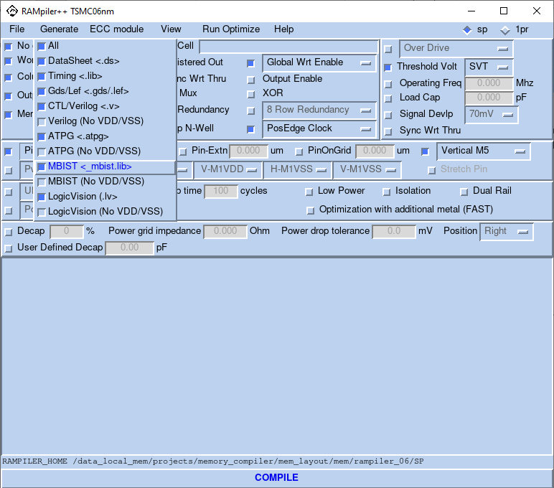

### LogicVision Bist Models

The “**LogicVisionBistModels**” option gives the user the option to select a LogicVision Bist Model to interface with the memory instance. Selecting this option will generate the wrapper RTL for the compiled block.

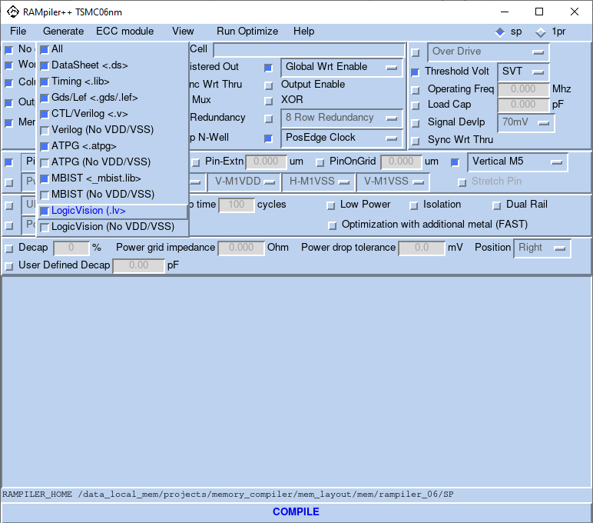

### Error Correction Code

The “**ECC**” option provides the user to insert Error Correction Codes. The user has 4 options:

* SECDED : Single Error Correct, Double Error Detect
* SEC : Single Error Detect, Single Error Correct
* ODDPARITY : Parity of bits is odd
* EVENPARITY : Parity of Bits is even

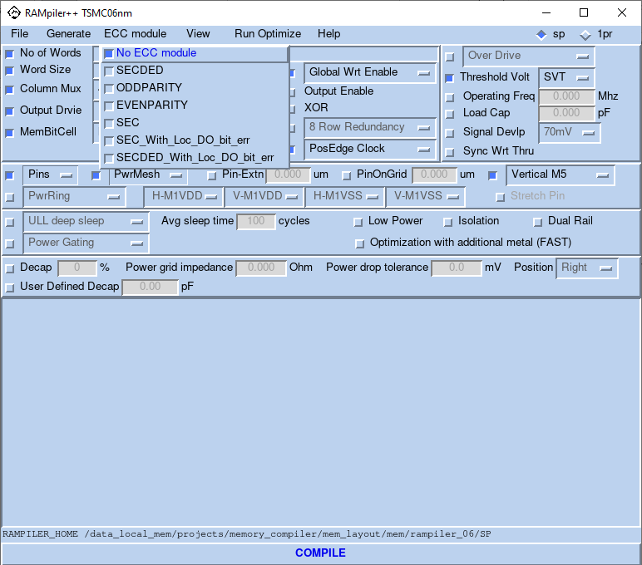

### Deep N Well

The user has the option to include deep N-Well while creating the memory instance using the “**DeepNWell**” option. This will add a solid deep N-Well under memory block for better noise immunity in the substrate in design.

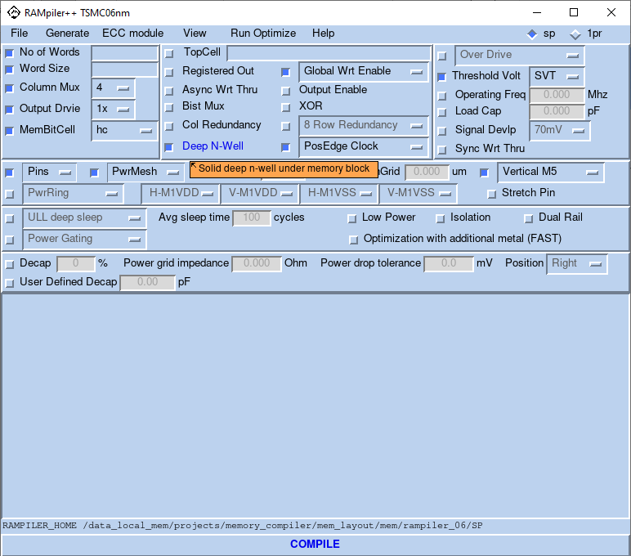

### Memory Cell Option

The user has the option of using the memory cell as per the requirement. The memory cell options available are.

|  |  |
| --- | --- |
| Memory Type | FFC/FF+ process |
| Single Port | TSMC 6T-SRAM SHD (0.0690µm2)  TSMC 6T-SRAM HD (0.0734µm2)  TSMC 6T-SRAM SHC (0.0864µm2)  TSMC 6T-SRAM HC (0.0907µm2) |

The TSMC 6T-SRAM SHD (0.0690µm2) memory cell is referred to as the “shd” cell in the GUI for Single Port.

The TSMC 6T-SRAM HD (0.0734µm2) memory cell is referred to as the “hd” cell in the GUI for Single Port.

HD and SHD bitcell need write assist.

The TSMC 6T-SRAM SHC (0.0864µm2) memory cell is referred to as the “shc” cell in the GUI - for Single Port.

The TSMC 6T-SRAM HC (0.0907µm2) memory cell is referred to as the “hc” cell in the GUI - for Single Port.

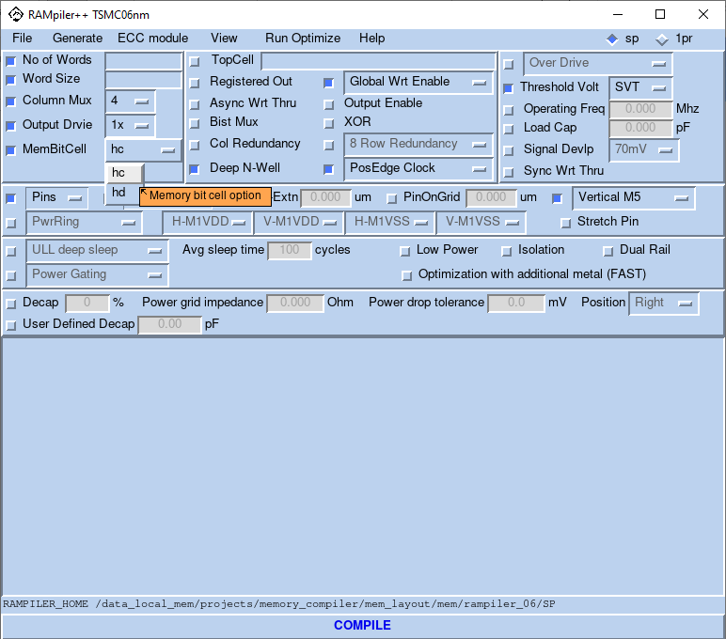

### Output Enable

The Output Enable option gives the option of having an output enable pin.

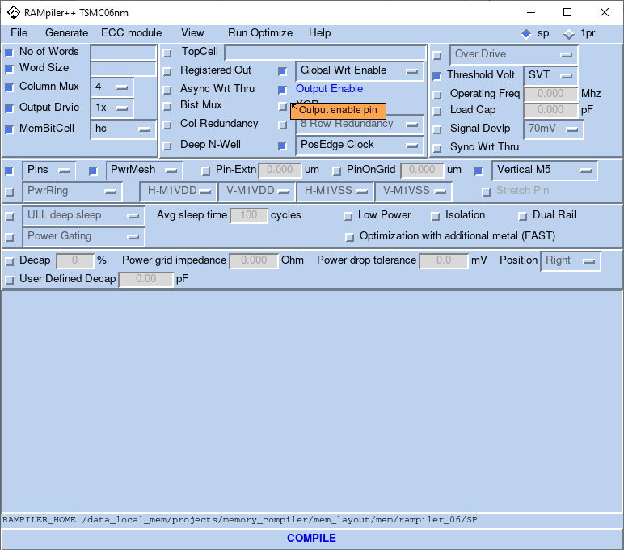

### Synchronous Write Through

The synchronous write through option allows the user to enable reading back the input data while performing memory write.



Figure 5. Synchronous write through timing diagram

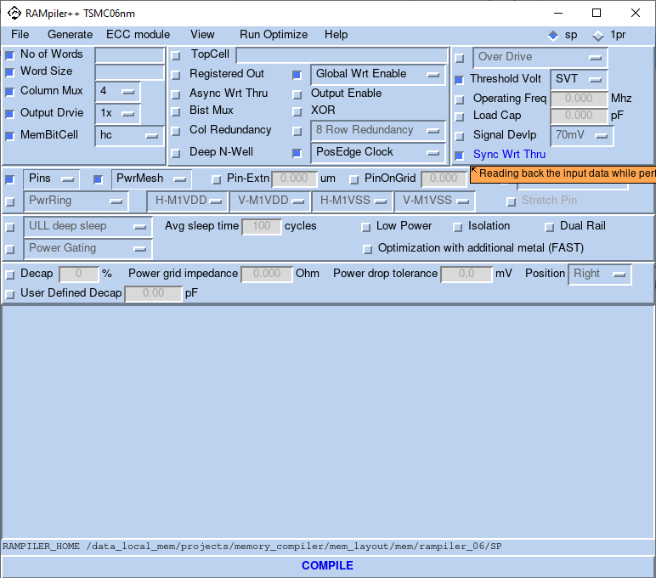

### Decap

The Decap option adds decoupling capacitances on the bottom of each instance according to the given Power Grid Impedance (in Ohm) and Power Drop Tolerance (in mV). Moreover, the compiler can also support putting only a certain percentage of the total required decoupling capacitances when the user does not want to take the area hit. However, we strongly recommend using 100% of the required amount of decaps.

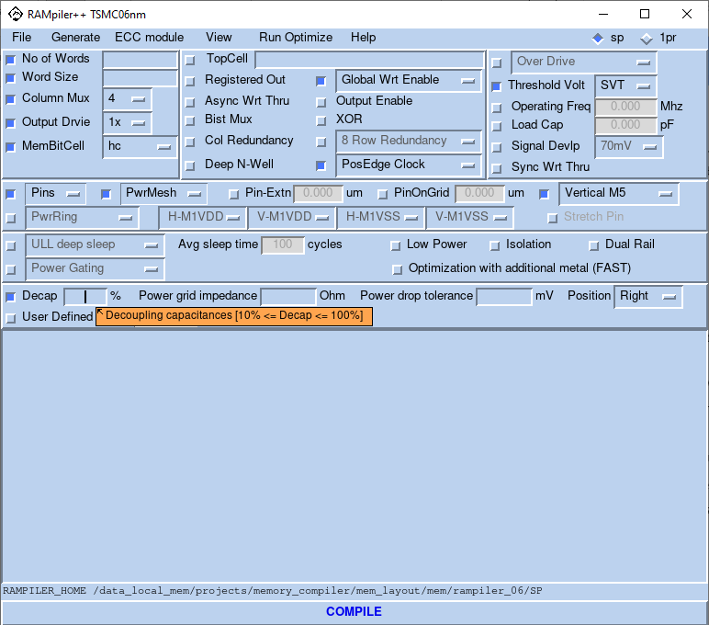

### Low Power Options

Low Leakage option enables the option of Ultra low leakage (ULL) with data retention. Compiler supports the following two ULL modes as different options:

* Light Sleep mode: requires the least amount of time to wake up, with less leakage saving.
* Deep Sleep mode: requires more time to wake up (usually more than one cycle), with more leakage saving.

The ULL control pins are listed as below.

* “LKRB_N”: “0” enable bit cell array ULL; “1” disable bit cell array ULL
* “LOLEAK_N”: “0” enable periphery circuit ULL; “1” disable periphery circuit ULL.

In low leakage mode, the output’s state is unchanged. The user can’t access memories in low leakage modes.

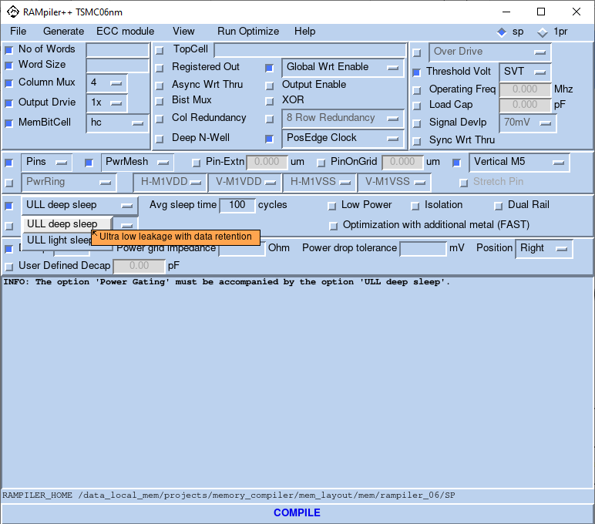



Figure 6. Time for entering/exiting low power mode

The above figure is showing how signals LOLEAK_N and LKRB_N need to be controlled for entering or exiting low power mode. During functional mode, these signals need to be held at ‘1’. To enter lower power mode, user needs to set the appropriate signal to ‘0’ after last command is complete. The setup time (wake up time) ***ts*** is the time taken for all internal power nodes to be stable (memory is ON). It is requirement time to exit to functional mode and be shown in datasheet. “Min sleep time” is requirement time for saving power is effective.

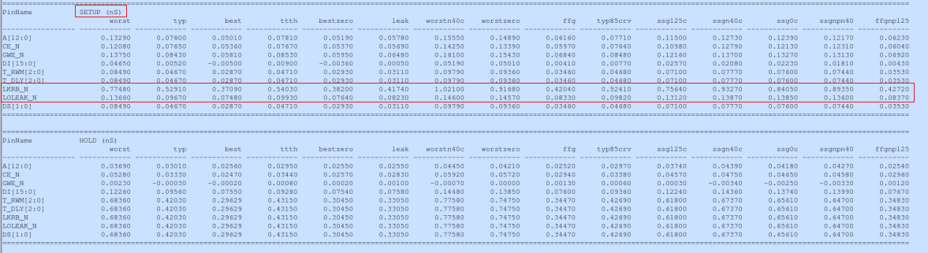

### Power Gating

Power Gating option enables SRAM power down function. The following two modes are supported:

* Power Gating mode: Periphery logic and memory array power down. Data stored in the memory array will be lost.
* Power Gating with data Retention mode: Periphery logic power down only, while the power for memory array is always on for data retention.

The Power Gating control pins are listed as below.

* “P_PWS”: “0” periphery logic power down; “1” periphery logic power up.
* “COREPWS”: “0” memory array power down; “1” memory array power up.

In power gating mode, output is ‘0’.

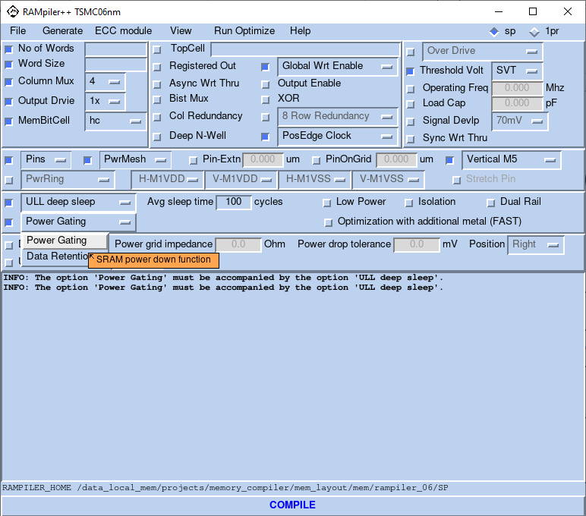

The following figure is showing how signals PWS_N and CORE_PWS_N need to be controlled for entering or exiting low power gating mode. During functional mode, these signals need to be held at ‘1’. To enter lower power mode, user need to set the appropriate signal to ‘0’ after last command is complete. If the last command is reading, user should wait 1 cycle to ensure last data out is captured. The setup time (wake up time) ***ts*** is the time taken for all internal power nodes to be stable (memory is ON).



Figure 7. Time for entering/exiting low power mode when last command is reading



Figure 8. Time for entering/exiting low power mode when last command is writing

### Dual Power Grid

The Dual Power option allows creations of memory configurations with two separate power supplies: one for periphery logic and the other for the memory bitcell.

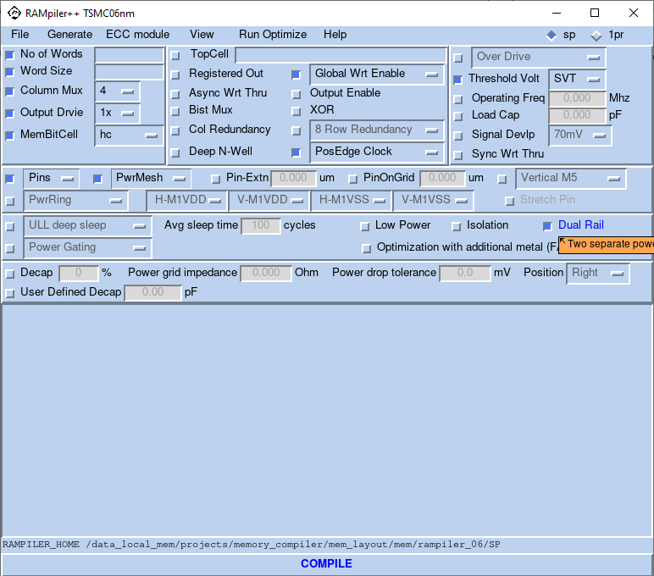

### Isolation

The Isolation option allows the user to isolate all inputs.

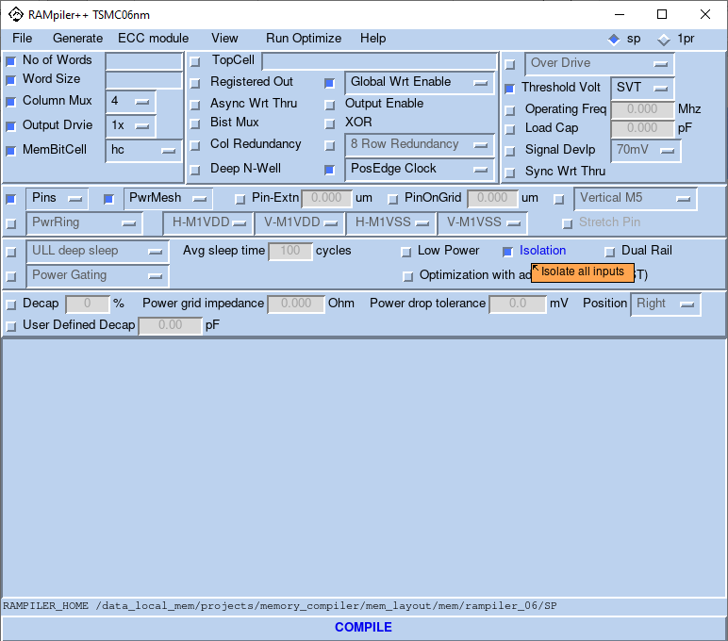

### Low Power

The Low power option generates low power memory.

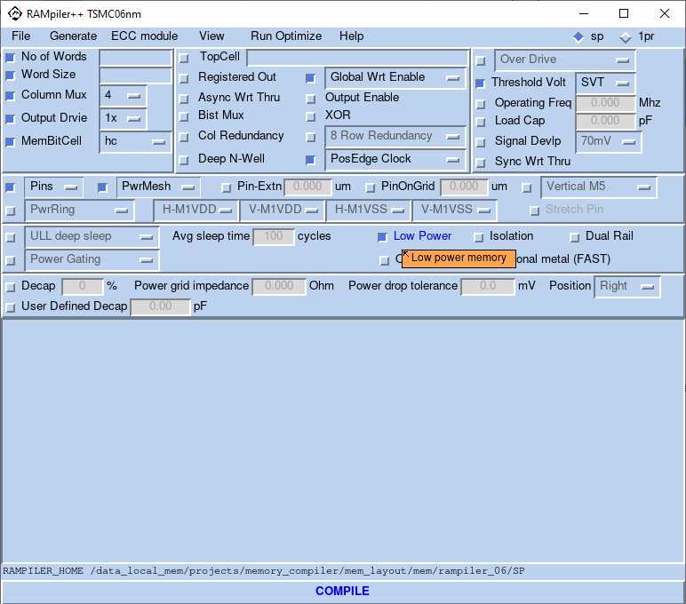

### Compile

The Compile button enables the user to create instances after specifying the required options.

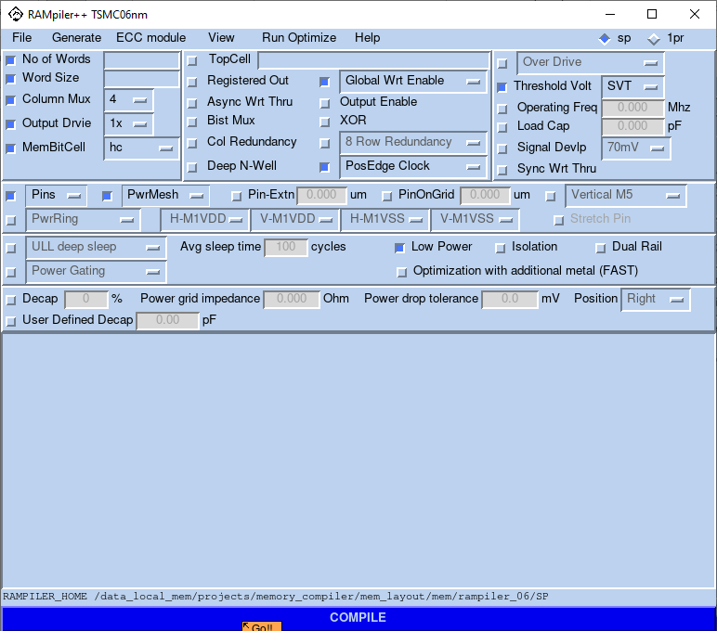

# RAMpiler+ Pin Definition and Truth Table for Single Port

Table 1. RAMpiler Single Port Pin Definition

|  |  |
| --- | --- |
| Port Name | Function |
| A[0:M-1]* | Address Bus (has address of the Access location in Memory) |
| T_A[0:M-1] | Bist Address |
| DI[0:N-1] | Data In Bus |
| T_DI[0:N-1] | Bist Data In Bus |
| DO[0:N-1]** | Data Out Bus |
| CLK | Clock |
| GWE_N | Global Read/Write Enable (low for write) |
| T_GWE_N | Bist Global Read/Write Enable (low for write) |
| BWE_N[0:N-1] / BYWE_N[0:N-1] | Bit Write Enable (low for write)  Byte Write Enable (low for write) |
| T_BWE_N[0:N-1] /  T_BYWE_N[0:N-1] | Bist Bit Write Enable (low for write)  Bist Byte Write Enable (low for write) |
| CE_N | RAM select (active low) |
| T_CE_N | Bist RAM select (active low) |
| OE_N | Output Enable (low for output) |
| T_OE_N | Bist Output Enable (low for output) |
| T_BE_N | Bist enable(active low) |
| T_AWT_N | Asynchronous write through(active low) |
| T_RWM | Read Write Margin |
| XOR_OUT | Xor output |
| SE | Scan enable (active high) |
| SI | Scan input |
| SO | Scan output |
| * M = log2(words) ***T_BE_N is the select signal for built in self-test. ** N = Bits per word | |

Table 2. Single Port Truth Table

|  |  |  |  |  |  |  |  |  |  |  |  |  |  |  |  |  |  |  |  |
| --- | --- | --- | --- | --- | --- | --- | --- | --- | --- | --- | --- | --- | --- | --- | --- | --- | --- | --- | --- |
| CLK | X | 0 |  | |  |  |  | | X | X | 0 | |  |  |  | |  | X | |
| T_BE_N | 1 | X | 1 | | 1 | 1 | 1 | | 1 | 0 | X | | 0 | 0 | 0 | | 0 | 0 | |
| T_AWT_N | X | 1 | 1 | | 1 | 1 | 1 | | 0 | X | 1 | | 1 | 1 | 1 | | 1 | 0 | |
| OE_N | 1 | 0 | 0 | | 0 | 0 | 0 | | X | X | X | | X | X | X | | X | X | |
| CE_N | X | X | 0 | | 0 | 0 | 1 | | X | X | X | | X | X | X | | X | X | |
| GWE_N | X | X | 1 | | 0 | 0 | X | | X | X | X | | X | X | X | | X | X | |
| BWE_N/  BYWE_N | X | X | X | | 1 | 0 | X | | X | X | X | | X | X | X | | X | X | |
| T_OE_N | X | X | X | | X | X | X | | X | 1 | 0 | | 0 | 0 | 0 | | 0 | X | |
| T_CE_N | X | X | X | | X | X | X | | X | X | X | | 0 | 0 | 0 | | 1 | X | |
| T_GWE_N | X | X | X | | X | X | X | | X | X | X | | 1 | 0 | 0 | | X | X | |
| T_BWE_N/  T_BYWE_N | X | X | X | | X | X | X | | X | X | X | | X | 1 | 0 | | X | X | |
| A | X | X | V | | V | V | X | | X | X | X | | X | X | X | | X | X | |
| DI | X | X | X | | X | V | X | | V | X | X | | X | X | X | | X | X | |
| T_A | X | X | X | | X | X | X | | X | X | X | | V | V | V | | X | X | |
| T_DI | X | X | X | | X | X | X | | X | X | X | | X | X | V | | X | V | |
| T_RWM | 011 (default) – This has to be used for normal read and write | | | | | | | | | | | | | | | | | | |
| CRAL | N, where N = Column number to be shifted on the left-hand side. N = 0 by default. | | | | | | | | | | | | | | | | | | |
| CRAR | N, where N = Column number to be shifted on the right-hand side. N = 0 by default. | | | | | | | | | | | | | | | | | | |
| RENF | 1 = Row Redundancy Enabled for RRAF , 0 = Row Redundancy Disabled for RRAF | | | | | | | | | | | | | | | | | | |
| RENS | 1 = Row Redundancy Enabled for RRAS , 0 = Row Redundancy Disabled for RRAS | | | | | | | | | | | | | | | | | | |
| RRAF | N, where N = Row address to be replaced (Quartet). N = 0 by default. | | | | | | | | | | | | | | | | | | |
| RRAS | N, where N = Row address to be replaced (Quartet). N = 0 by default. | | | | | | | | | | | | | | | | | | |
| DO | Z | OD | DO | | DO | DI | OD | | DI* | Z | OD | | DO | DO | DI | | OD | DI* | |
| XOR_OUT | A ^ OE_N ^ CE_N ^ GWE_N ^ BWE_N | | | | | | | | | T_A ^ T_OE_N ^ T_CE_N ^ T_GWE_N  ^ T_BWE_N | | | | | | | | | |
|  |  | | | | | | | | |  | | | | | | | | | |
| DS | 11 (default) is the control signals for deep sleep, provides the most leakage reduction and the least bitcell stability in deep sleep mode | | | | | | | | | | | | | | | | | |
|  | Normal | | | Light sleep | | | | Deep sleep | | | | Power Gating with data retention | | | | Memory shut down | | |
| COREPWS_N | 1 | | | 1 | | | | 1 | | | | 1 | | | | 0 | | |
| P_PWS_N | 1 | | | 1 | | | | 1 | | | | 0 | | | | 0 | | |
| LKRB_N | 1 | | | 1 | | | | 0 | | | | 0 | | | | 0 | | |
| LOLEAK_N | 1 | | | 0 | | | | 0 | | | | 0 | | | | 0 | | |
| DO | Unchange | | | Unchange | | | | Unchange | | | | 0 | | | | z | | |
| DI = Data In (write)  DI* = Data In Asynchronous  DO = Data Out  IV = Invalid  OD = Old Data  U = Unknown  V = Valid  X = Don’t Care  Z = High Impedance  Note: Invalid Operation -- First Clock Cycle After Power-Up is dedicated to the Resetting of the internal nodes and should be ignored. | | | | | | | | | | | | | | | | | | | |

**Basic Write Single Port**

During the basic write operation, we need to set the global read/write enable to 0, chip select enable to 0 and the data to be written onto DI. Different modes of read/write are also available like the bit write, byte write and global write. In case of bit-wise write operation, selective masking of the data input bits is done by setting the bit write enable signals BWE_N’s appropriately. Byte-wise mode of operation is facilitated by the BYWE_N and T_BYWE_N signals. During the test/bist mode of operation, the corresponding bist counterparts of the above mentioned signals dictate the operation. As long as the T_BE_N (bist enable, active low) signal is 1, the values of T_DI, T_CE_N, T_BWE_N, T_GWE_N, TA and T_OE_N don’t matter.

**Basic Read Single Port**

During a read operation all the signals are in the same state as in write operation except that global write enable is set to 1 in this case. The data read from the memory location appears on the output data bus in the same clock cycle or the subsequent cycle depending on whether the outputs are registered or not.

A truth table representing the behavior of the memory block has been presented in the previous pages, Table 2. The table covers the memory responses for different values of the control signals. Also, since there is a single port, there are no potential conflicts like two ports reading/writing to the same location and so on.

A timing/waveform diagram is also shown to have a pictorial representation of the above description in Figure 11 and Figure 12.

# RAMpiler+ Naming Convention

dti_sp(pp)_(lp)_(ll/lli)(pg/pgr)(dr)_tm06(ff)(od)(hvt/lvt/ulvt)_(nw)x(ws)_ )(ep/op/sec/secde*)_(i)(t)(aw)(1/2/4/8/16/32)(bw/byw/ww)(r)(1/3/9)x(oe)(r)(c) _(shd/hd/shc/hc)_(isol)

Table 3. Naming Convention for Top Level

|  |  |  |
| --- | --- | --- |
| Field Value | Description |  |
| dti | Dolphin Technology |  |
| sp | Single Port SRAM Block without redundancy | Default |
| spp | SinglePort Plus [with Column Redundancy] |  |
| sppp | Single Port Plus Plus [with Row Redundancy] |  |
| shd/hd/shc/hc | Bit cell type |  |
| ll | Low Leak- deep sleep |  |
| lli | Low Leak- light sleep | Optional |
| dr | Dual Power Rail | Optional |
| pg | Power gating | Optional |
| pgr | Power gating with data retention | Optional |
| Tm06/07 | Foundry = TSMC Technology = 06/07nm | Default |
| ffp/ffc | Process |  |
| od | Over Drive |  |
| hvt | Higher Threshold Voltage logic device | Optional |
| lvt | Low Threshold Voltage logic device | Optional |
| ulvt | Ultra low Threshold Voltage logic device | Optional |
| nw | Number of Words |  |
| ws | Word Size |  |
| secded | Single Error Correct Double Error Detect | Optional |
| sec | Single Error Correct | Optional |
| op | Odd Parity | Optional |
| ep | Even Parity | Optional |
| * | Number of parity bits | Optional |
| i | Clock = Negative Edge. If not present, Clock = Positive Edge | Optional |
| t | BistMux is selected and Test Pins are generated. | Optional |
| x | XOR the outputs of the bist mux | Optional |
| aw | Asynchronous Write through is enabled. | Optional |
| 4 | Column Mux select Option 4 | Default for SP |
| 8 | Column Mux select Option 8 |  |
| 16 | Column Mux select Option 16 |  |
| 32 | Column Mux select Option 32 |  |
| bw | Bit Write |  |
| byw | Byte Write |  |
| ww | Global Write | Default |
| r | Registered Output | Optional |
| 1x | Output Driver Strength 1x | Default |
| 3x | Output Driver Strength 3x |  |
| 9x | Output Driver Strength 9x |  |
| oe | Output enable | Optional |
| r | Redundant Row(s) created | Optional |
| c | Redundant Column(s) created | Optional |
| pn | Power Ring Enabled | Optional |
| po | Power Ring Enabled with Overlap | Optional |
| isol | Isolation | Optional |

# Command Line Syntax

#command:

**./rampileplus_tsmc06nm $Phy_rows $Phy_cols $Column_Mux $RgstrdOut $Output_Drive $BistMux $Cap_load $TopCellName $DateSheet $Timing $Netlist $Gds $Verilog $CntrlmV $LowPower $Wrt_Enable $Byte_Size $RowRed $RowRed_num $ColRed $PwrRing $PwrRingOvrlap $Oper_Freq $Stretch $Pins $PowerMesh $H_VD $V_VD $H_VS $V_VS $Soft_Hard $RdWrtMargin $AsyncWrtThru $DeepNWell $Clock_Edge $BitBlast $Metal5 $FuseTopModel $no_thick $rdl $Simulation_Ring_model $VT $mem_VT $MemBitCell $OD $Output_Enable $XOR $PinOnGrid $Pin_Ext $ECC $LogicVision_model $Mentor_model $Sync_Wrt_Thru $Decap $Power_grid_impedance $Power_drop_tolerance $PPO $ULL $Average_sleep_time $Dual_Rail $Power_Gating $PWD**

# $Phy_rows = 256 ; ## Physical rows (= No_of_Words/muxoption)

# $Phy_cols = 384 ; ## Physical columns (= Word_Size*muxoption)

# $Column_Mux = 16 ; ## Column mux select option [4|8|16|32]

# $RgstrdOut = 0 ; ## Registered output [0|1]

# $Output_Drive = 9.0 ; ## Output drive strength [1.0(0.1pF)| 3.0(0.25pF)|9.0(1.0pF)]

# $BistMux = 0 ; ## BistMux is selected and test pins are generated [0|1]

# $Cap_load = 0.000 ; ## Load capacitance on the output pin (pF*1000)

# $TopCellName = "dti_sp_tm06ll_8192x24_wt16ww9xoe_c_shd" ; ## Name of the topcell

# $DateSheet = 1 ; ## Generate datasheet (*.ds) [0|1]

# $Timing = 1 ; ## Generate timing file (*.lib) [0|1]

# $Netlist = 1 ; ## Generate netlist (*.ckt) [0|1]

# $Gds = 1 ; ## Generate GDS (*.gds)

# $Verilog = 0 ; ## Generate Verilog & CTL model (*.v, *.ctl) [0|1|2] (0: no verilog & CTL, 1: verilog with VDD/VSS & CTL, 2: verilog without VDD/VSS & CTL)

# $CntrlmV = 0 ; ## Select cntrlmap mV. Default is 0

# $LowPower = 0 ; ## Select Low power [0|1]

# $Wrt_Enable = 0 ; ## Global|Bit|Byte write enable [0|1|2]

# $Byte_Size = 8 ; ## set as default

# $RowRed = 0 ; ## Row redundancy option [0|1]

# $RowRed_num = 2 ; ## 4/8 redundant rows [1|2]

# $ColRed = 0 ; ## Column redundancy option [0|1]

# $PwrRing = 0 ; ## Power ring option [0|1]

# $PwrRingOvrlap = 0 ; ## Power ring is overlapped for VDD and VSS [0|1]

# $Oper_Freq = 0.000 ; ## Specifies the frequency(Mhz) of operation for the memory instancae. The worst corner operating frequency will be used as default

# $Stretch = 0 ; ## Input/output pins are stretch to the edge of the power ring or deep n-well [0|1] when the power ring or deep n-well option is on

# $Pins = "111" ; ## Selecte the metal for the pins [100-111]. [metal1|metal2|metal3]

# $PowerMesh = "011" ; ## Selecte the metal for the power pins [000-011]

# $H_VD = 0 ; ## Horizontal metal in the powr ring for VDD [0|1|2|3|4] (0: no power ring, 1: metal1, 2: metal2, 3: metal3, 4: metal4)

# $V_VD = 0 ; ## Vertical metal in the powr ring for VDD [0|1|2|3|4] (0: no power ring, 1: metal1, 2: metal2, 3: metal3, 4: metal4)

# $H_VS = 0 ; ## Horizontal metal in the powr ring for VSS [0|1|2|3|4] (0: no power ring, 1: metal1, 2: metal2, 3: metal3, 4: metal4)

# $V_VS = 0 ; ## Vertical metal in the powr ring for VSS [0|1|2|3|4] (0: no power ring, 1: metal1, 2: metal2, 3: metal3, 4: metal4)

# $Soft_Hard = 0 ; ## Select fuse input [0|1] (0: hard repair, 1: soft repair) ** NOT AVAILABLE **

# $RdWrtMargin = 1 ; ## Read/Write Margin to control over the sense amplifier [1]. The default setting for the field is '011' (000 - 111)

# $AsyncWrtThru = 1 ; ## Asynchronous write though [0|1]

# $DeepNWell = 0 ; ## Select deep n-well [0|1]

# $Clock_Edge = 0 ; ## inverted clock [0|1|2]

# $BitBlast = 0 ; ## Buses to be bit-blased [0|1] ** NOT AVAILABLE **

# $Metal5 = 0 ; ## Metal5 VDD/VSS (0: no metal5, 1: vertical metal5, 2: horizontal metal5)

# $FuseTopModel = 0 ; ## Choice of top metal for fuse [5|6|7|8|9] ** NOT AVAILABLE **

# $no_thick = 0 ; ## Top thick fuse [1|2] ** NOT AVAILABLE **

# $rdl = 0 ; ## Presence of redistribution layer on fuse [0|1] ** NOT AVAILABLE **

# $Simulation_Ring_model = 0 ; ## Presence of simulation ring [0|1]

# $VT = 0 ; ## Specifies a threshold voltage for peripheral circuit [0|1|2|3] (0: svt, 1:hvt, 2:lvt, 3:ulvt)

# $mem_VT = 0 ; ## Specifies a threshold voltage for memory cell [0|1]

# $MemBitCell = "shd" ; ## Memory option depending the compiler & technology

# $OD = 0 ; ## Select over-drive or low-voltage [0|1] (0: no over drive, 1: over drive)

# $Output_Enable = 1 ; ## Output enable pin option [0|1]

# $XOR = 0 ; ## XORing of the output of the bist muxes [0|1]

# $PinOnGrid = 0.000 ; ## Value of the grid to which the pins must be snapped [0|0.14] ** NOT AVAILABLE **

# $Pin_Ext = 0.000 ; ## Value of the extension of the pins in um addition to the default of 0.14um

# $ECC = 0 ; ## Generate ECC module (*_ecc.v) [0|1|2|3|4|5|6] (0: no ECC, 1: Single error correction double error detection, 2: Odd Parity, 3: Even parity, 4: Single error correction

# ## 5:Single error correction with DO bit error, 6: Single error correction double error detection with DO bit error

# $LogicVision_model = 1 ; ## Generate Logic Vision file (.lv) [0|1|2] (0: no logicvision, 1: logicvision with VDD/VSS, 2: logicvision without VDD/VSS)

# $Mentor_model = 3 ; ## Generate ATPG/MBIST file [0|1|2|3] (0: no ATPG/MBIST, 1: ATPG with VDD/VSS, 2: MBIST with VDD/VSS, 3: Both ATPG & MBIST with VDD/VSS

# ## [4|5|6] (4: ATPG without VDD/VSS, 5: MBIST without VDD/VSS, 6: Both ATPG & MBIST without VDD/VSS

# $Sync_Wrt_Thru = 0 ; ## Synchronous write [0|1]

# $Decap = 0.0 ; ## Decap [-1.1 <= Decap <= 1.1]

# $Power_grid_impedance = 0.000 ; ## Power grid resistance (Ohm)

# $Power_drop_tolerance = 0.000 ; ## Power drop tolerance (mV)

# $PPO = 0 ; ## Optimization with additional metal layer [0].

# $ULL = 0 ; ## Create ULL configurations [0|1|2] (0: no ULL, 1: deep sleep, 2:light sleep)

# $Average_sleep_time = "100" ; ## Average sleep time <entry frame> cycles. Default is 100

# $Dual_Rail = 0 ; ## Create dual rail configurations [0|1]

# $Power_Gating = 0 ; ## Create power gating configurations [0|1|2] (0: no paoer gating, 1: power gating, 2: power gating with data retention)

# ## [3|4|5] (3: isolation, 4: power gating with isolation, 5: power gating with data retention and isolation)

**Example:**

#sample:

#! /bin/csh -f

./rampileplus_tsmc06nm 4 160 8 0 1.0 0 0.000 dti_sp_tm06_32x20_8ww1x_shd 1 0 0 1 0 0 0 0 8 0 2 0 0 0 0.000 0 111 011 0 0 0 0 0 1 0 0 0 0 0 5 1 0 0 0 0 shd 0 0 0 0.000 0.000 0 0 0 0 0 0 0.0 0.000 0.000 0 0 100 0 0 $PWD

# Ip-tagging for the GDS

The Ip –tagging for the Gds is shown as below



Example:



# READ/WRITE Timing Diagram Without Output Register



Figure 9. Read/ Write Timing Diagram without Registered Output

# READ/WRITE Timing Diagram With Output Register



Figure 10. Read/ Write Timing Diagram with Registered Output

Table 4. Timing diagram parameter description

|  |  |
| --- | --- |
| Parameter | Description |
| Tcc | Cycle time |
| Tas | Address set-up time |
| Tah | Address hold time |
| Tds | Input data set-up time |
| Tdh | Input data hold time |
| Tgwes | Global Write enable set-up time |
| Tgweh | Global Write Enable hold time |
| Tcss | Chip select (CE_N) set-up time |
| Tcsh | Chip select hold time |
| Toch | Output data hold from clock ^, Read mode |
| Taa | Output data delay from clock ^, Read mode |
| Toh | Output data hold from clock ^, Write mode |
| Tod | Output data delay from clock ^, Write mode |
| Tdoe | Output data valid from Output Enable (OE_N)  |
| Tdox | Output data hold from OE_N  |
| Tdoz | Output data disabled from OE_N ^ |
| ˄ Rising Edge  ˅ Falling Edge  All parameters are in ns.  All set-up and hold times are referenced to the rising edge of CLK | |

# Dolphin Technology Redundancy Architecture

As an example, a Dolphin Technology’s 8kx32 column mux 16 with row and column redundancy is provided. The RAM will have two row quartets plus two columns of redundancy built in as outlined in Figure 11. There are two sets of 8 fuses for Row (one enable and 7 addresses), there are two sets of 5 fuses for the Column (4 bits plus one added IO). The redundant Columns are placed in the outer edges of the two half while the two quartets of Redundant Rows are present at the bottom. There will be one input to put the fuse box in soft repair mode.

The fuse box utilizes the core voltage, requires a Power-On-Reset, POR, signal rise of < 750ps and with a width of > 500ps, but fuse box generates its own internal clocks. After the POR goes high, there is a 5ns (Worst case) settling time for the output data to be stable. The POR signal can be from any source like a reset, external,…. the signal must be available after the memory is powered up and can use a delay in POR path if the reset is coincident with the system, power up to make sure POR rises after the memory is powered up. Post rise behavior of POR does not matter and the signal can stay high or switch low after the required 500ps. The initial state of fuse output is low and if a fuse is blown, the output will be pulled high indicating a blown fuse. The fuses have a 1:1 mapping with the outputs (i.e. there is no decode which occurs in order to affect the {RENS, RENF, RRAS[6:0], RRAF[6:0], CRAL[4:0], CRAR[4:0]} signals).

5 bits for 16 Columns

5 bits for 16 ColumnsCLK_A

2 x 7 Address bits for redundant row address.

Row_EN

Left Half

0 to 15

Right Half

16 to 31

0 to 511

Redundant Column

Control Circuitry

Column Encoder

Redundant Row Pair

0 to 511

Figure 11. Dolphin Technology 8Kx32 cm16 Memory With Row/Column Redundancy

Considering the diagram of Figure 13, the given structure will have 28 fuses incorporated for each block of 8K x 32.The control bits are binary codes which will be used to select the desired row/column to be shifted. Thus, a binary code of all 0’s will result in no redundant row/column while a particular bit set to 1 will result in the shift in the rows/column. Table 1 outlines the mapping for the column redundancy. The top level pin numbering used is the same as the fuse numbers to avoid any confusion.

Table 5. Fuse Box Column Bit Map of the 8K x 32

|  |  |  |  |
| --- | --- | --- | --- |
| Left Hand Side | | Right Hand Side | |
| Column bits [4:0] | Shifted Column | Column bits [4:0] | Shifted Column |
| 00000 | None | 00000 | None |
| 00001 | 0 | 00001 | 16 |
| 00010 | 1 | 00010 | 17 |
| 00011 | 2 | 00011 | 18 |
| 00100 | 3 | 00100 | 19 |
| 00101 | 4 | 00101 | 20 |
| 00110 | 5 | 00110 | 21 |
| 00111 | 6 | 00111 | 22 |
| . | . | . |  |
| . | . | . | . |
| . | . | . | . |
| . | . | . | . |
| . | . | . | . |
| 10000 | 15 | 10000 | 31 |

For the row redundancy case, there is a row REN that is set in conjunction with the address that is being replaced. The 2 least significant bits are ignored since row redundancy is done in a quartet. The address is checked and mapped between the two 7-address bits in case the REN is set resulting in that address being replaced. The physical map of the SRAM block is given in Figure 14.

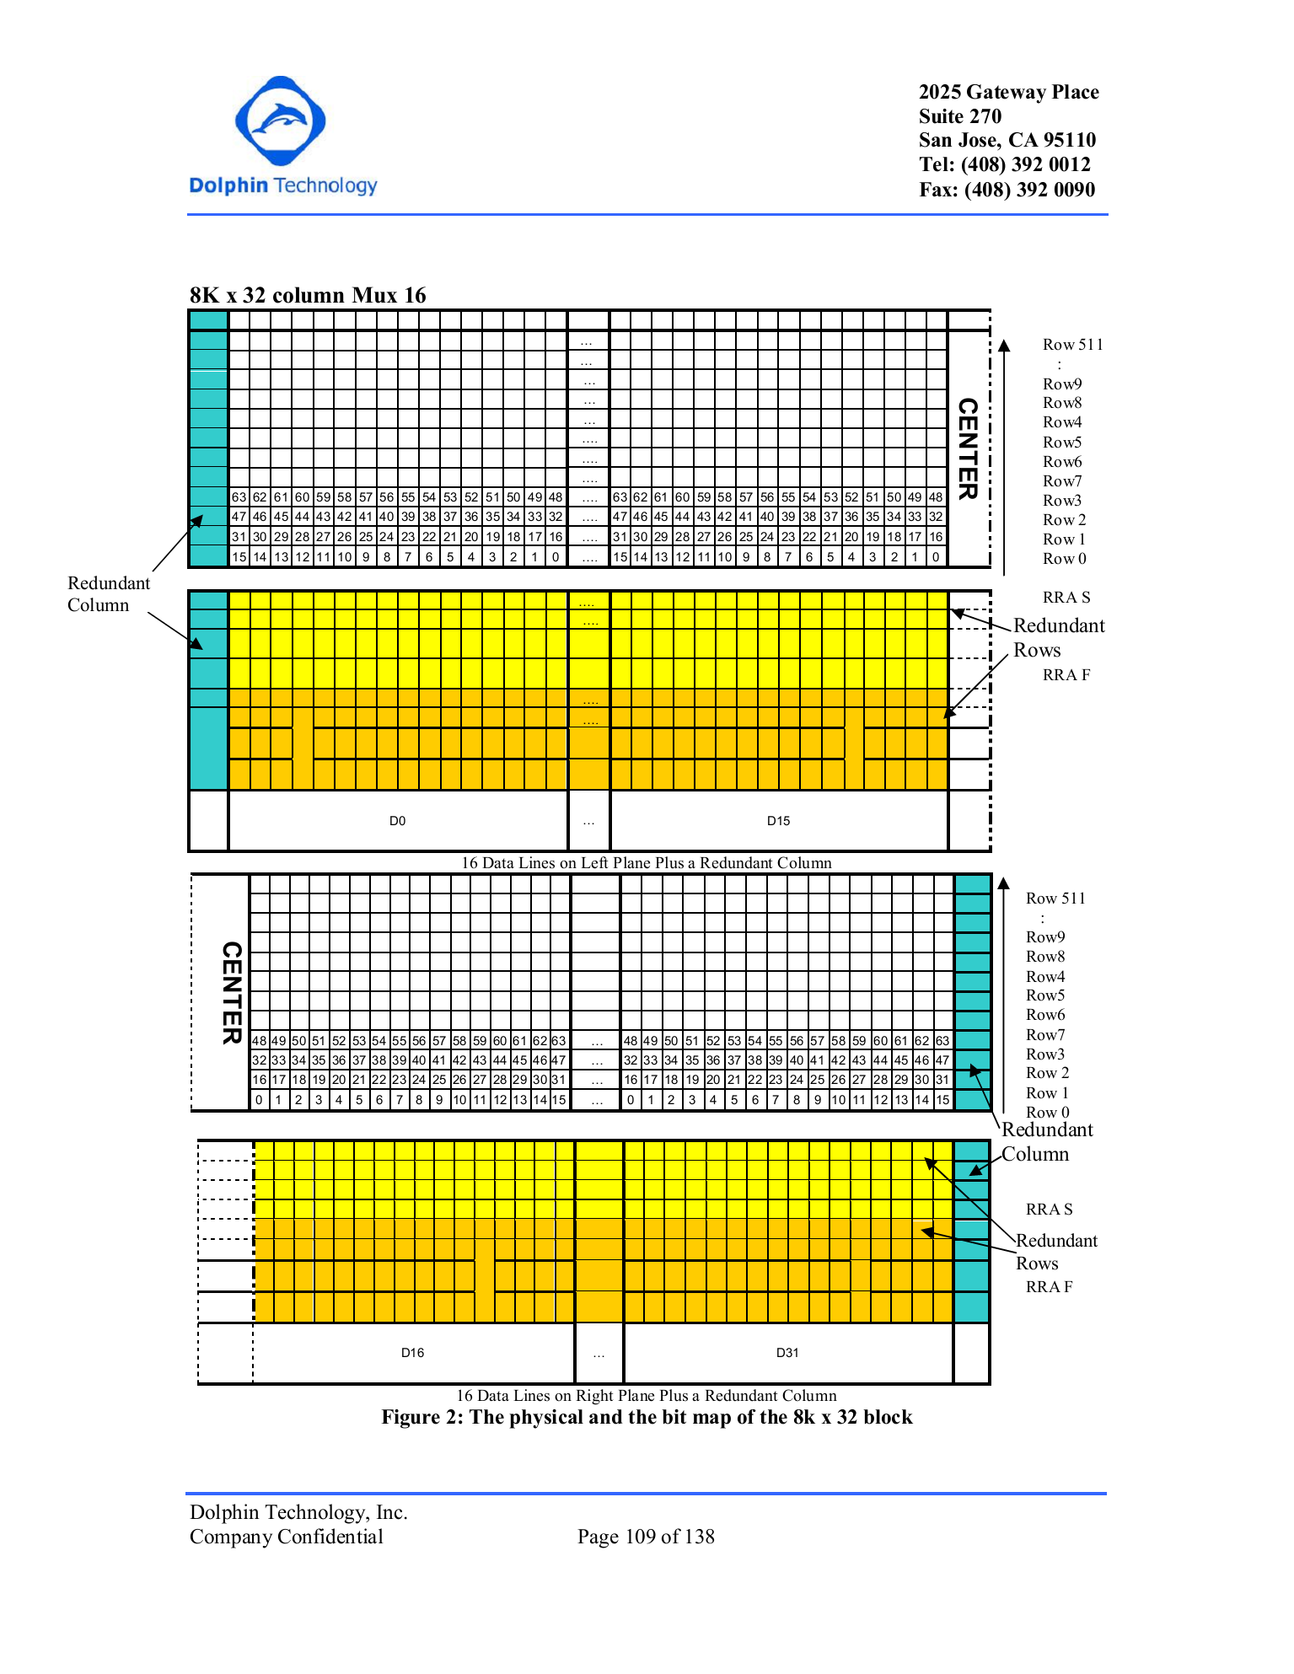

Figure 12. Physical Map and Bit Map of the 8k x 32 Block

# Dolphin Technology Row Redundancy Architecture

For the row redundancy case, there is a row redundancy enable, REN that is set in conjunction with the address that is being replaced. The 2 least significant bits are ignored since row redundancy is done in a quartet. The address is checked and mapped between the two sets of address bits in case the REN is set resulting in that address being replaced. Figure 15 outlines a sample fuse box configuration and the repair mechanism.

Table 6. SRAM Logical and Physical Characteristics

|  |  |  |  |  |  |  |  |  |  |  |  |  |
| --- | --- | --- | --- | --- | --- | --- | --- | --- | --- | --- | --- | --- |
| Physical | Logic Array | |  |  | row mux | col mux | Physical Array | | Fuse box | | | # of fuses |
|  | Xl | Yl |  |  | Nr | Nc | Xp | Yp | 1 quartet | | 1 Col | 2 quartets and  2 columns |
|  | N | d | nr | nc | 2 ^ nr | 2^nc | 2 ^ nr | 2^nc * d | REN | RRA | CRA |  |
| 8 k x 32 | 8192 | 32 | 9 | 4 | 512 | 16 | 512 | 512 | 1 | 7 | 5 | 26 |
|  | | | | | | | | | | | | |
| Notations: | | | | | | | | | | | | |
| N | # of address locations | | | | | | | | | | | |
| d | # of data bits | | | | | | | | | | | |
| nr | # row addresses | | | | | | | | | | | |
| nc | # column addresses | | | | | | | | | | | |
| Nr | row mux | | | | | | | | | | | |
| Nc | column mux | | | | | | | | | | | |
| Xl | X dimension of logical array | | | | | | | | | | | |
| Yl | Y dimension of logical array | | | | | | | | | | | |
| Xp | X dimension of physical array | | | | | | | | | | | |
| Yp | Y dimension of physical array | | | | | | | | | | | |

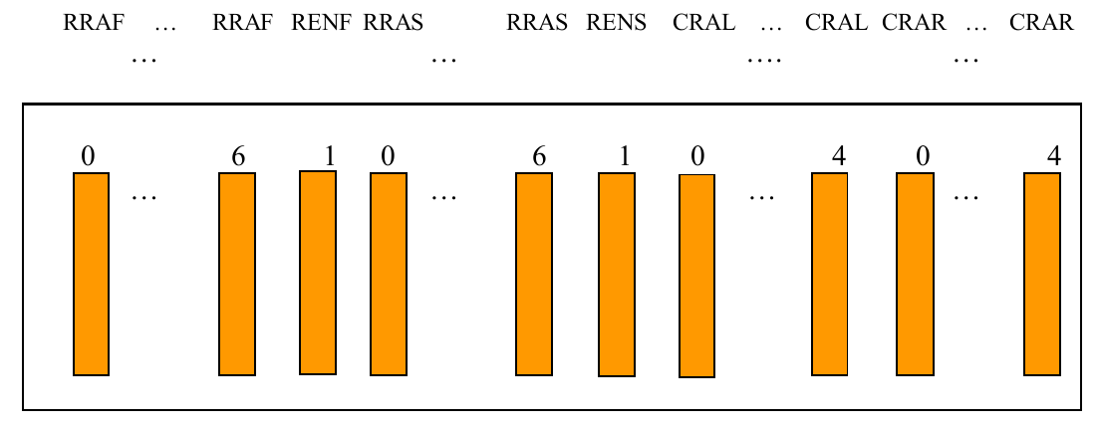

Figure 13. Fuse Box and the Repair Mechanism

**Fuse Box**

8 fuses for repair of 1 quartet

RENF-enable for row 0

RRAF [6:0] = Redundant row address 1 without LSB

RENS-enable for row 1

RRAS [6:0] = Redundant row address 2 without LSB

5 fuses for repair of 1 column

CRAL [4:0] = Redundant column Left side

CRAR [4:0] = Redundant column Right side

2 quartets redundancy and two-column redundancy.

Total of 26 fuses for each block of 8K x 32.

NOTE: Dolphin recommends placing a buffer every 1-2mm of fuse wire.

# Dolphin Technology Fuse Architecture

SOFT_HARD = 0 is soft repair

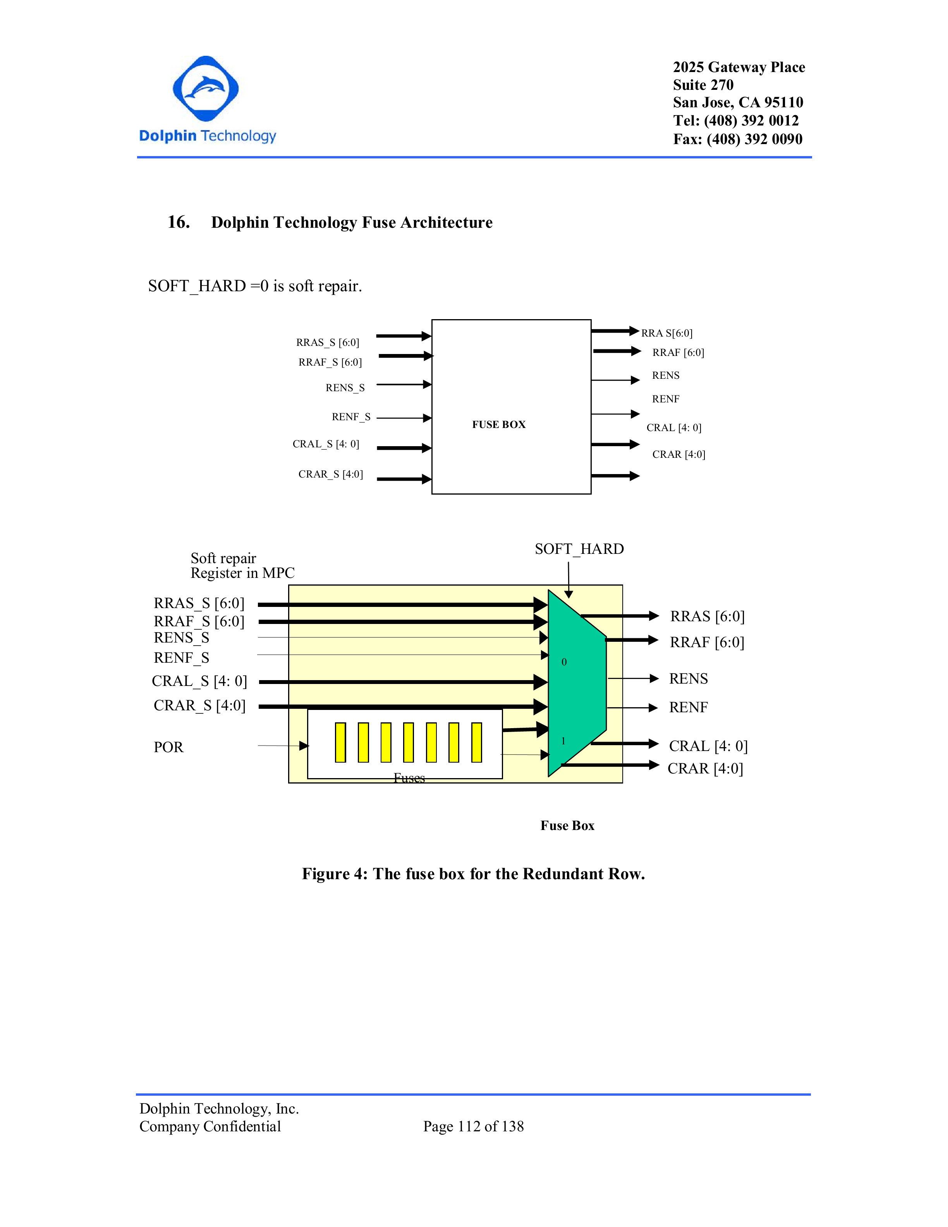

Figure 14. Fuse Box for the Redundant Row.

# Dolphin Technology Fault Verilog Modeling

The memory compiler generates a fault verilog model if redundancy option is selected.

The fault injection verilog model reads a file called "cell.data" which contains the description about the fault verilog. This file consists of multiple entries with two fields: address (in bold), data (see Figure 15). Fault verilog reads this file using “readmemh” function, hence use hexadecimal representation to specify contents of this file.

The user can inject faults and repair the faulty rows or columns using the column and row redundancy features. (The verilog models that we have developed introduces a stuck-at-1 if the bit position is odd, else a stuck-at-0).

Here is an example of such a file:

If fault Verilog configuration has 8 data bits and 8 address bits. Any bit position that is “1” in the data field indicates a fault (stuck-at-1 or a stuck-at-0) for that particular address, see Figure 16.

D0, D2, D4, D6 model stuck at 0 fault and D1, D3, D5, D7 Model stuck at 1 fault for “00” address . “cell.data” file needs to be created by the user.

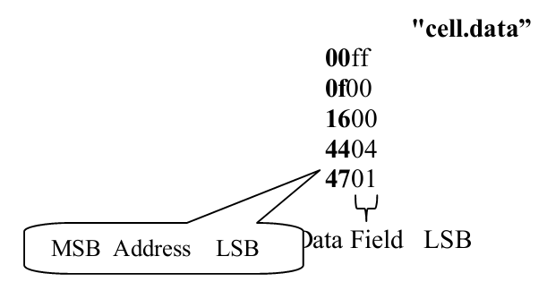

Figure 15. Visual Representation of Data File Given to Fault Verilog

|  |  |  |  |  |  |  |  |  |  |  |  |  |  |  |  |
| --- | --- | --- | --- | --- | --- | --- | --- | --- | --- | --- | --- | --- | --- | --- | --- |
| 0 | 0 | 0 | 0 | 0 | 0 | 0 | 0 | 1 | 1 | 1 | 1 | 1 | 1 | 1 | 1 |
| A7 | A6 | A5 | A4 | A3 | A2 | A1 | A0 | D7 | D6 | D5 | D4 | D3 | D2 | D1 | D0 |

Figure 16. 00ff Maps to 8 Address and 8 Data Bits as Shown

**NOTE:** Since hexadecimal representation is used, when the Data bits are not a multiple of 4, Data bits and Address bits will overlap. It is left to the user has to specify inputs accordingly.

If fault Verilog has 10 data bits and 6 address bits (Figure 17).

|  |  |  |  |  |  |  |  |  |  |  |  |  |  |  |  |
| --- | --- | --- | --- | --- | --- | --- | --- | --- | --- | --- | --- | --- | --- | --- | --- |
| 0 | 0 | 0 | 0 | **0** | **0** | **0** | **0** | 1 | 1 | 1 | 1 | 1 | 1 | 1 | 1 |
| A5 | A4 | A3 | A2 | **A1** | **A0** | **D9** | **D8** | D7 | D6 | D5 | D4 | D3 | D2 | D1 | D0 |

Figure 17. 00ff Maps to 6 Address and 10 Data Bits When Data Bits Not a Multiple of 4

Overlap between data and address bits (shown in bold) has to be taken care in this configuration and specified in the cell.data file as hexadecimal representation is used.

**NOTE:** When Sum of Data and Address bits are not a multiple of 4.

If fault Verilog 10 data bits and 4 address bits

In this Example, D0 models a stuck at 0 and rest of data bits don’t model a fault for “0101” address (Figure 18)

|  |  |  |  |  |  |  |  |  |  |  |  |  |  |  |  |
| --- | --- | --- | --- | --- | --- | --- | --- | --- | --- | --- | --- | --- | --- | --- | --- |
| 0 | 0 | 0 | 1 | 0 | 1 | 0 | 0 | 0 | 0 | 0 | 0 | 0 | 0 | 0 | 1 |
|  |  | A3 | A2 | A1 | A0 | D9 | D8 | D7 | D6 | D5 | D4 | D3 | D2 | D1 | D0 |

Figure 18. 2401 Mapping to 10 Address and 4 Data Bits

# Error Correction Codes (ECC)

Error Correction Codes (ECC)

The compiler provides the user with 4 options for Error Correction:

1. SECDED : Single Error Correct Double Error Detect
2. SEC : Single Error Correct
3. ODDPARITY : Parity bit is stored for Odd parity
4. EVENPARITY : Parity bit is stored for Even Parity

The diagram below represents the mapping between the ECC block and memory

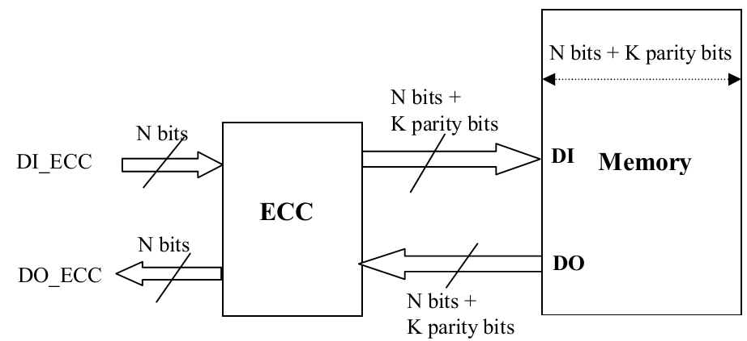

Figure 9. Memory Interface With ECC Compiler for Global Write

Additionally, the ECC block generates certain signals based on the ECC option selected by the user. They are as follows:

**SECDED**

Using this option, the user can correct single bit errors and detect errors in up to 2 bits.

The “ECC” block generates an error detection flag ERR_OUT[1:0] based on the syndrome and overall parity created from the data in the memory. The ERR_OUT flag is decoded as follows:

|  |  |
| --- | --- |
| ERR_OUT[1:0] | Description |
| 00 | No error has occurred |
| 01 | Double error has been detected. Not correctable. |
| 10 | Parity error has occurred. Correctable. |
| 11 | Single error has been detected and corrected |

**SEC**

An overall flag named ERR_OUT is generated which is equal to 1 if an error is detected.

**ODDPARITY**

An overall flag named ODDPARITY_ERROR is generated which is equal to 1 if a single bit error is detected.

**EVENPARITY**

An overall flag named EVENPARITY_ERROR is generated which is equal to 1 if a single bit error is detected.

**BIT /BYTE WRITE SCHEME**

The following section provides information pertaining to using the compiler with the ECC option in Bit/Byte Write mode. The steps listed in this section must be followed and are NOT optional.

In Bit/Byte Write Mode, additional Bit/Byte write enable “BWE_N_ECC / BYWE_N_ECC” pins are made available to the user through the ECC block.

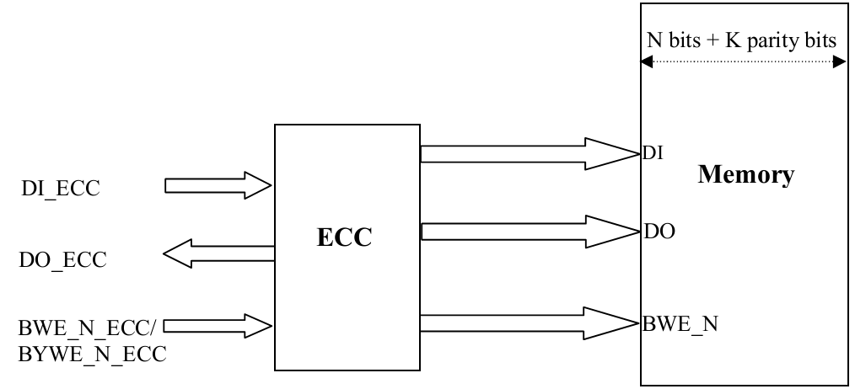

Figure 10. Memory Interface With ECC Compiler for Bit/Byte Write

**Memory**

N bits + K parity bits

DO

BWE_N

DI

DI_ECC

DO_ECC

BWE_N_ECC/

BYWE_N_ECC

**ECC**

If the user wishes to avail the bit write option, he/she must do so in 2 steps below.

Step 1: The user must read the contents of the address location the user wishes to perform a bit/byte write into.

Step 2: The user may now perform a bit/byte write to the memory. However, the bits that won’t be written to must be replaced with the contents of the corresponding bit locations from Step 1 and fed to the ECC to compute the correct parity bit values. i.e. DI_ECC must be modified to have a combination of the new bits to be written and the old bits from the read cycle in Step 1.

# Appendix A: Datasheet description

The figure below is showing the datasheet generate from compiler. It shows Power-Performance-Area, setup/hold and input cap of the instance.

* Area

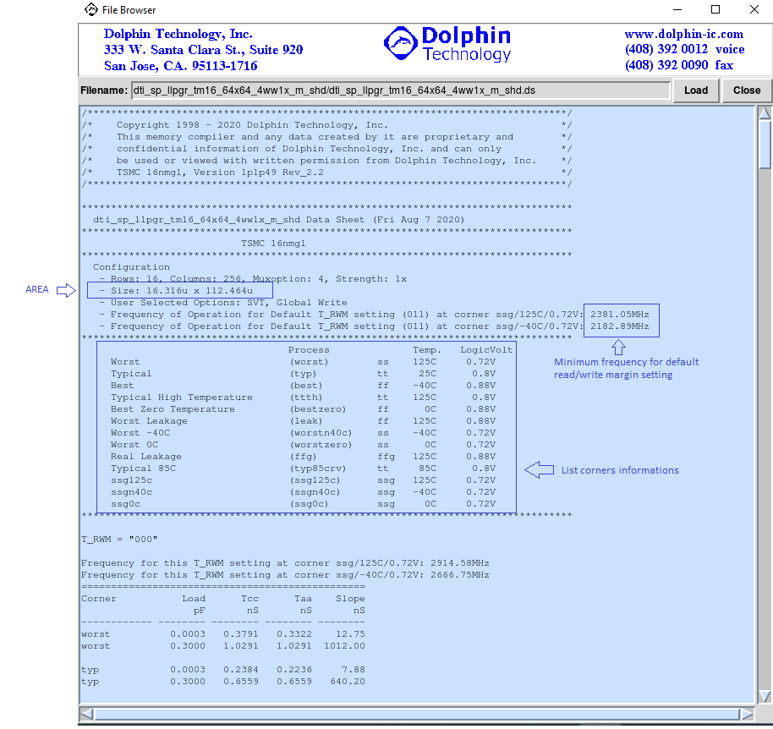

* Cycle/Access Time

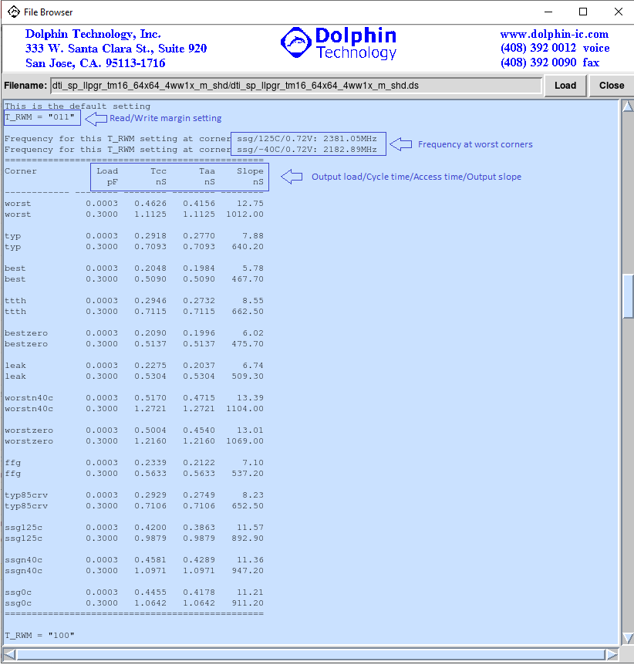

* Dynamic and leakage power

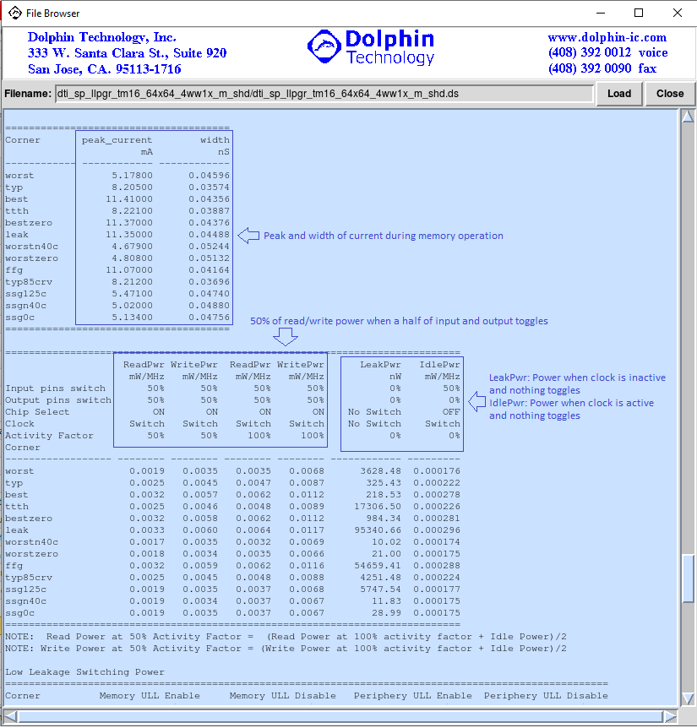

* The figure below is showing dynamic and leakage power for each power mode.

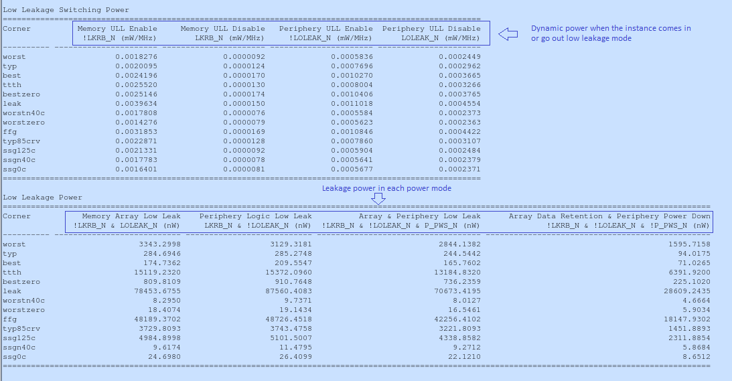

* Setup/Hold

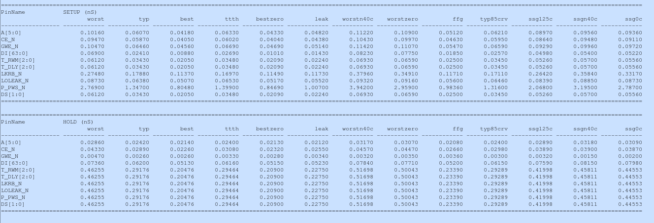

* Input capacitance

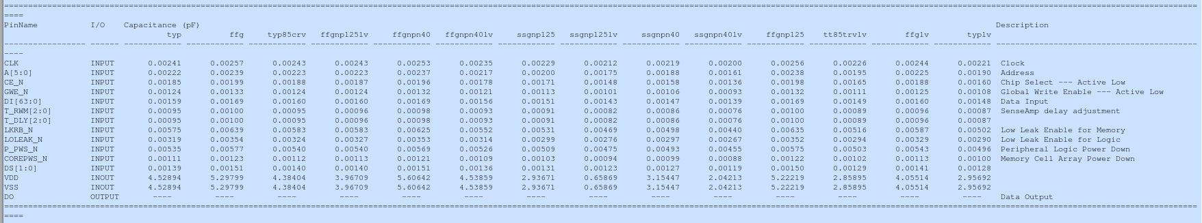

# Appendix B: Optimizing for AREA

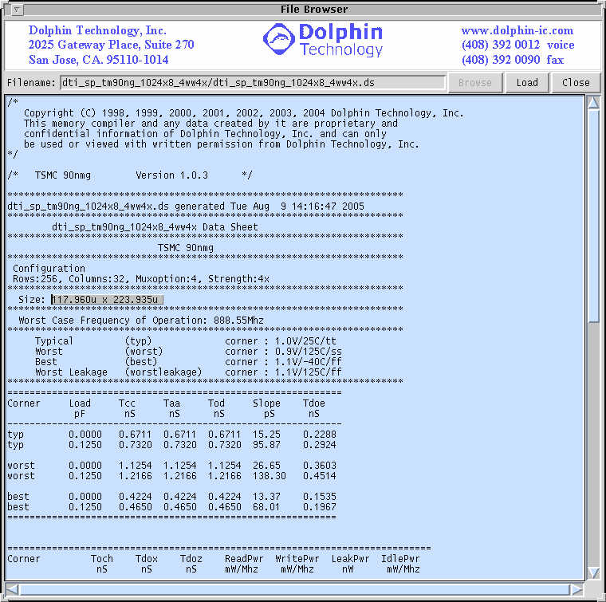

The above figure shows the datasheet generated from the compiler for 1kx8 configuration with column mux 4. The area of the macro is 117.960*223.935 = 26415.372.This configuration seems short and fat.

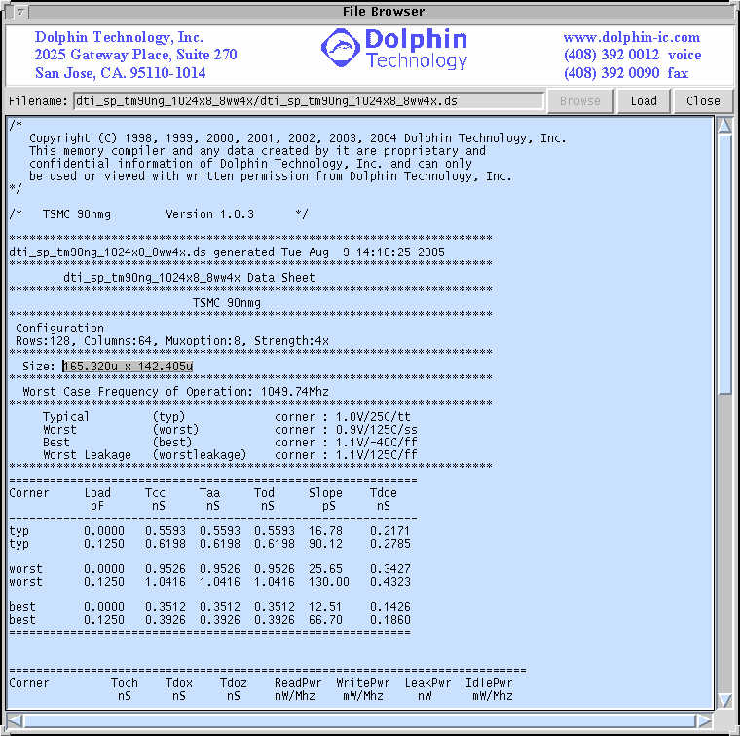

The figure above shows the datasheet generated from the compiler for 1kx8 configuration with column mux 8. The area of the macro is 165.320*142.405= 23542.394. As is evident, this configuration is better in AREA than the same configuration with column mux 4. Also, this leads to a squarer configuration than the column mux 4 case.

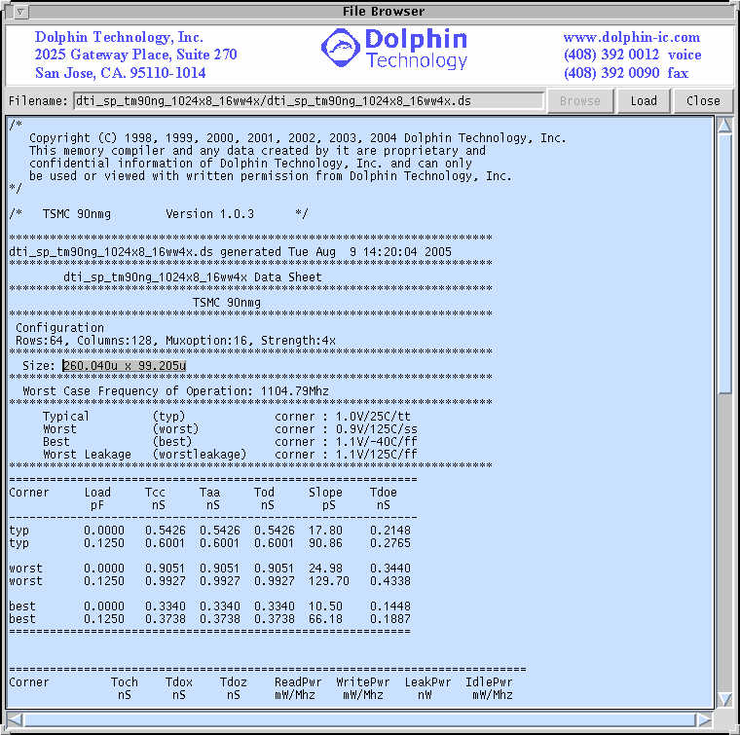

The figure above shows the datasheet generated from the compiler for 1kx8 configuration with column mux 16. The area of the macro is 260.040*99.205 = 25797.268. As is evident, this configuration is greater in AREA than the same configuration with column mux 8. This configuration seems to be tall and skinny.

So, In conclusion, to optimize for AREA, the best option usually would be to select the column mux which makes the memory squarer.

# Appendix C: Optimizing for Timing

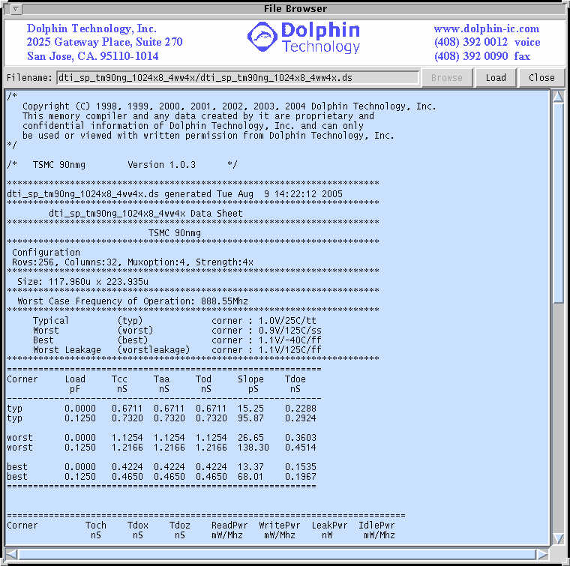

The worst case timing for the ram shown above in the datasheet is 1.1254ns. A 1kx8 macro with column mux 4 has been used. The number of physical rows is 256.

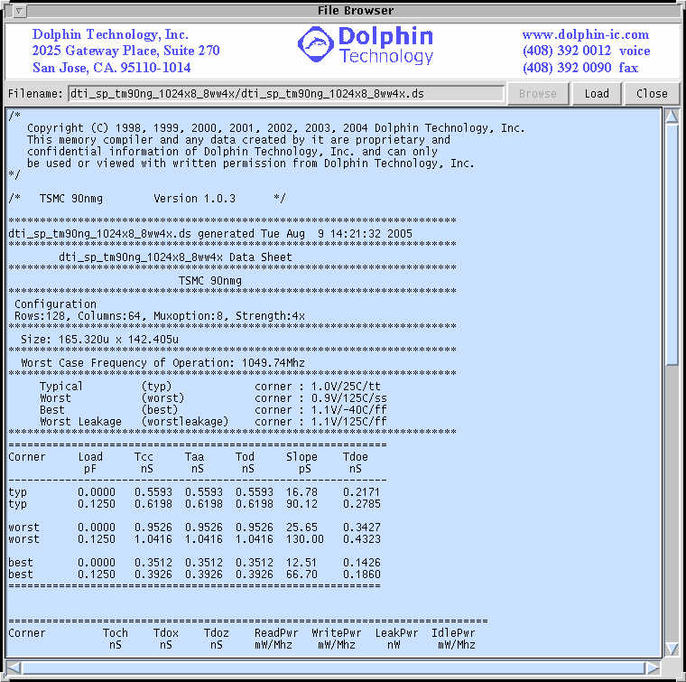

The worst case timing for the ram shown above in the datasheet is 0.9526ns, which is a huge improvement from the above case. The same 1kx8 macro has been used as before, but the column mux option has been changed to 8. As a result, even though the number of physical columns are doubled, the number of physical rows are halved to 128 thus speeding up the bitlines and the read and write operations of the memory.

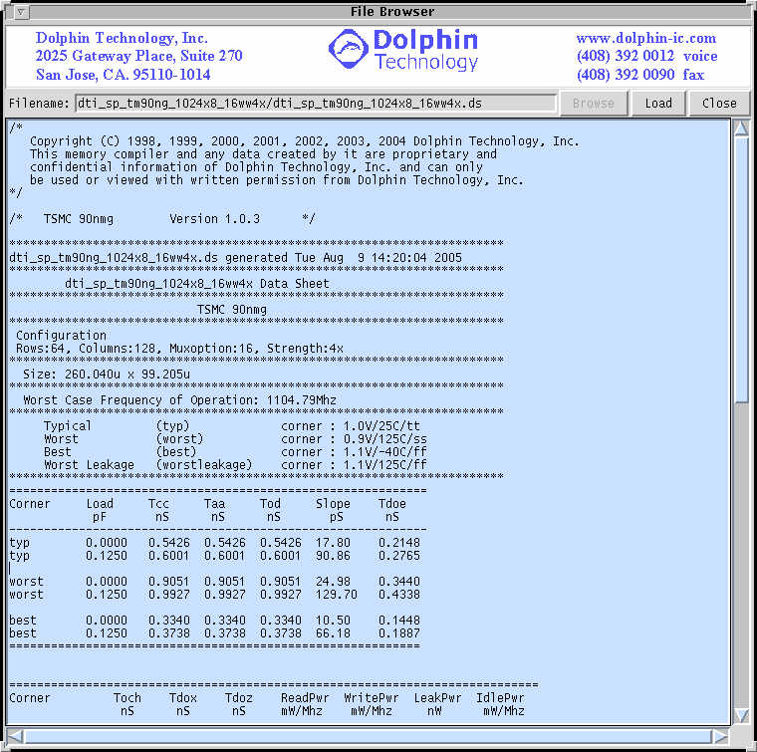

The worst case timing for the ram shown above in the datasheet is 0.9051ns, which is a further improvement from the above case for column mux 8. The same 1kx8 macro has been used as before, but the column mux option has been changed to 16. As a result, even though the number of physical columns are doubled again, the number of physical rows have now halved to 64 thus speeding up the bitlines and the read and write operations of the memory.

There is a trade-off between using a higher mux option to shorten the bitlines and introducing higher RC due to presence of more IO’s. One might require having to go through multiple mux options to come up with an optimum configuration.

# Appendix D: LefGraphic

The sample LefGraphic is shown in the figure below. There is an option in the compiler where the user can view the lef for the macro in the graphic format to look at the pins and the blockages.

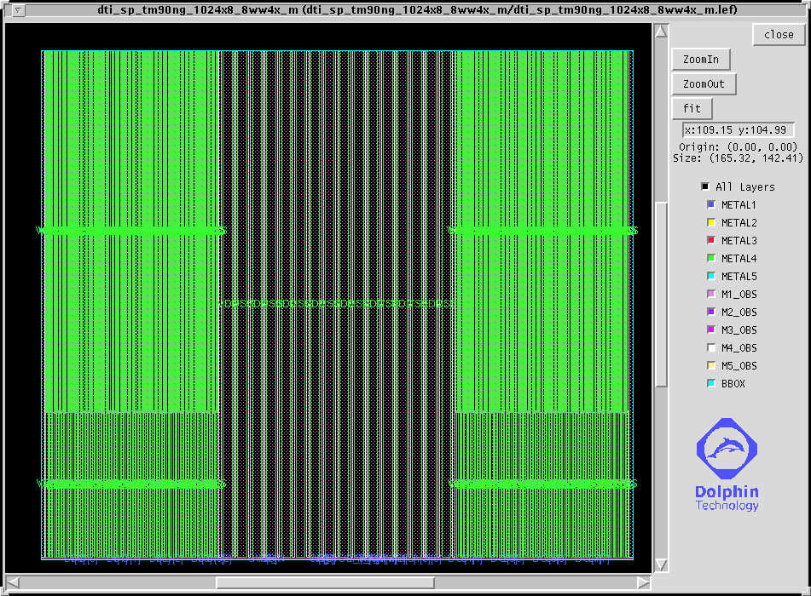

The graphic viewer is very flexible. The user can fit the macro to the window, zoom in and zoom out using the buttons. The user also has option of selecting the metals to be viewed along with the blockages. The next picture shows the pins when zoomed in. The best way to zoom in is to right click and drag the mouse in the desired area. This way, the user can zoom into any particular location.

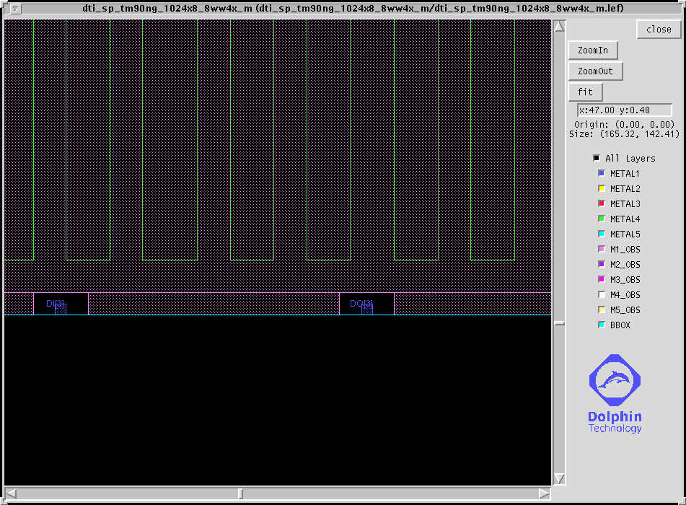

# Appendix E: Read Write Margin Settings

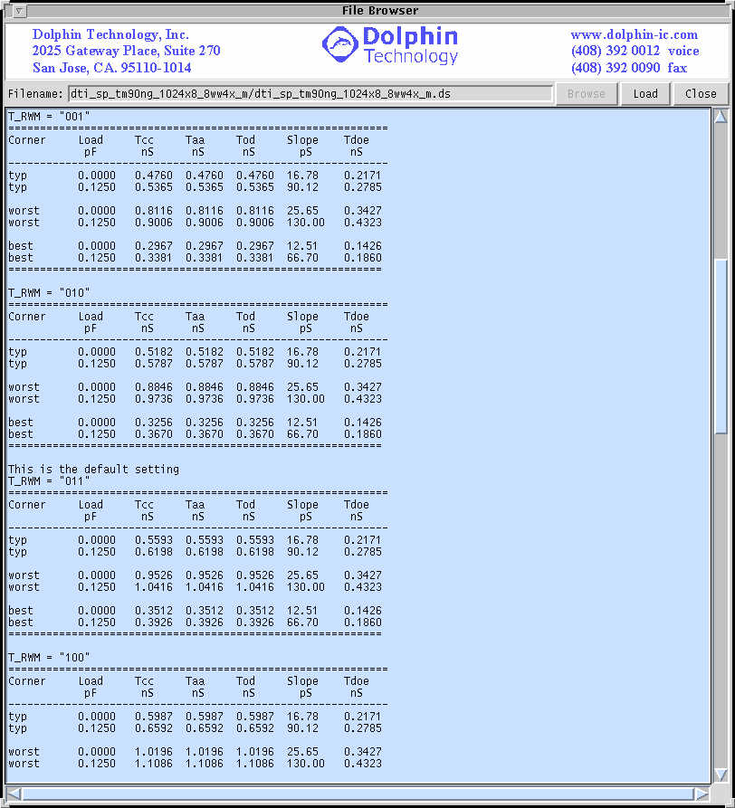

The user has the option to generate the timing for different settings for the Read/Write Margin. Default setting for these pins are “011”. By decreasing this value towards “000”, it is possible to speed up the read and write operations of the memory. As can be seen, at T_RWM = 001, worst case timing is 0.8116ns which when compared to 1.0196ns at T_RWM = 100 is a 25.6% improvement.

# Appendix F: Dolphin Technology Power Architecture

Dolphin Technology offers compilers with and without redundancy option RAMpiler++. The RAMpiler++ enables the user to generate memories with built-in combinations of Row, Column, and Row/Column redundancies as well as no redundant blocks without area and speed penalty. The purpose of this document is to provide guidelines for proper power hook-up to these memories.

**Dolphin Technology Power Architecture**

Dolphin Technology’s RAMpiler family provides two power hook-up options. The user can define whether the power to the macro is through power ring or it is through M4 hookup from the top by simply selecting the power ring option on the compiler. We recommend connecting the power from the top rather than the power ring option. In case of the power ring selection, the user can select which metal line (M1, M2, M3, M4) runs horizontal and which ones vertical as well as which is VDD and which layer is VSS. If not checked, power pins (VDD/VSS) will be available on M4 which is already arrayed on top of the macro and can be used to provide sufficient power to different parts of the memory as required. Following is the RAMpiler options related to power hook-up.

1. Frequency: The user can specify the frequency of operation. It determines the width of the power ring. The power values reported in the data sheet are also dependent on the frequency of operation.
2. Power Ring: The user can select the power ring option.
3. Power Ring Overlap: The user can select whether he wants a power ring with overlapped metal lines for VDD and VSS or non-overlapped metal line for VDD and VSS.
4. H-VDD: The user can select the metal (METAL1, METAL2, METAL3, METAL4) for top and bottom VDD when the power ring option is selected.
5. H-VSS: The user can select the metal (METAL1, METAL2, METAL3, METAL4) for top and bottom VDD when the power ring option is selected.
6. V-VDD: The user can select the metal (METAL1, METAL2, METAL3, METAL4) for left and right VDD when the power ring option is selected.
7. V-VSS: The user can select the metal (METAL1, METAL2, METAL3, METAL4) for left and right VDD when the power ring option is selected.
8. Pins: The user can select the metal (METAL1, METAL2, METAL3) for the input /output pins.
9. Stretch Pins: The user can select if he/she wants to stretch the pins to the edge of the power ring. This option can be selected only if there is power ring.

The SRAM block can be viewed as four separate parts: I/O, Control, X decoder and SRAM cell section as outlined in Figure 19.



Figure 19. Dolphin Technology Memory Block Structure

Considering the diagram of Figure 19, any given structure will have either power ring surrounding the block or pins provided for power connection to the macro from the top. Since the power ring power connection is simply connecting to the metal ring, this document will mainly outline the proper power connection to the macro from the top to M4 as outlined in Figure 20. Please note that all dimensions are exaggerated and the VDD/VSS M4 positions can be different for each compiler. The purpose of the figure is to provide a basic visual scenario.



Figure 20. Dolphin Technology’s Power Strap Scheme

When the power ring option is off, the M4 VDD/VSS will have pins that can be picked up by M5. The height of the I/O is about 20um depending on the memory block and needs the most power pick-up from the top. We recommend at least two pick up per line in this region. The control section is the second most important region as far as proper power connection is concerned and need to have multiple connections of VDD/VSS. In the SRAM area, some power connection will be sufficient since the memory cells receive their power from the bottom and control section. In order to satisfy boundary condition, complete VSS ring is provided on the top, bottom, and sides of the SRAM area. Following is the break down of the % power consumed for different regions for the two M5 and M6 connection options.

Power connection is made based on the following diagram. Use a layer of horizontal metal to tap to our top level metal 4 first.



Then use a vertical layer to tap to the horizontal metal.



**Multiple Block Placement Methodology (Tiling)**

In case the design requires larger blocks than the maximum allowed by the compiler, smaller configurations are used to create the desired block. By tiling the memories, one can either benefit in speed or achieve the density requirement. Figure 14 outlines a couple of sample block placement for tiling memory blocks.

**Optimizing for Area**

Optimizing for area is achieved by making any of the tile elements as large as possible to reduce the total number of instances. The total amount of area used by peripheral circuitry is reduced hence achieving smaller overall size of the block. Also, the total overhead for redundancy is reduced as well.

**Optimizing for Power and Performance**

Optimizing for speed is done by using shorter or shallower memory blocks for the tiles. This will add to the total number of instances and makes the overall block size higher at the expense of area. One positive side effect of this is that the total dynamic power for the block is also reduced. Optimizing for power is simply achieved by using more tiles and only turning one on at a time. The most optimized tiles are always the most square ones if they meet the performance requirements.

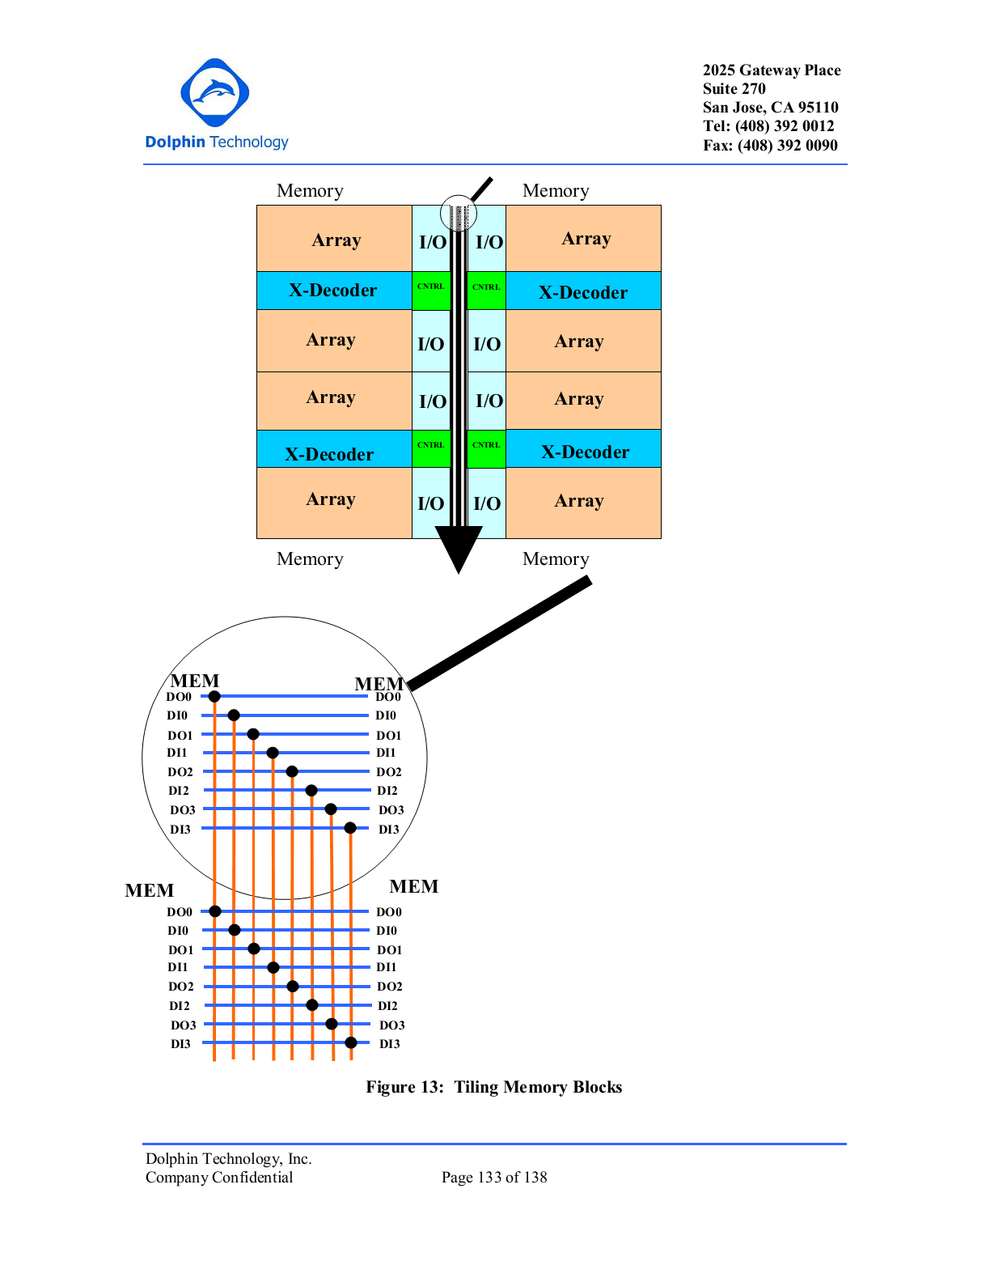

DO and DI’s of the opposite memories are connected in M5 (Blue) (wire-OR) and connected to the other blocks using M6 (Red). The Do’s can be logically Muxed using the OE signal of the memory. The DI’s, Addresses and Controls are simply tied together except for the MSB address bits that are used to control the Chip selects.

Buffering for the group of 4 can be placed between section of the memories but all the top level routing will be in M5 and M6 allowing the memories to practically abut together.

Figure 21. Tiling Memory Blocks

**STRETCH PINS TO THE EDGE OF THE POWER RING**

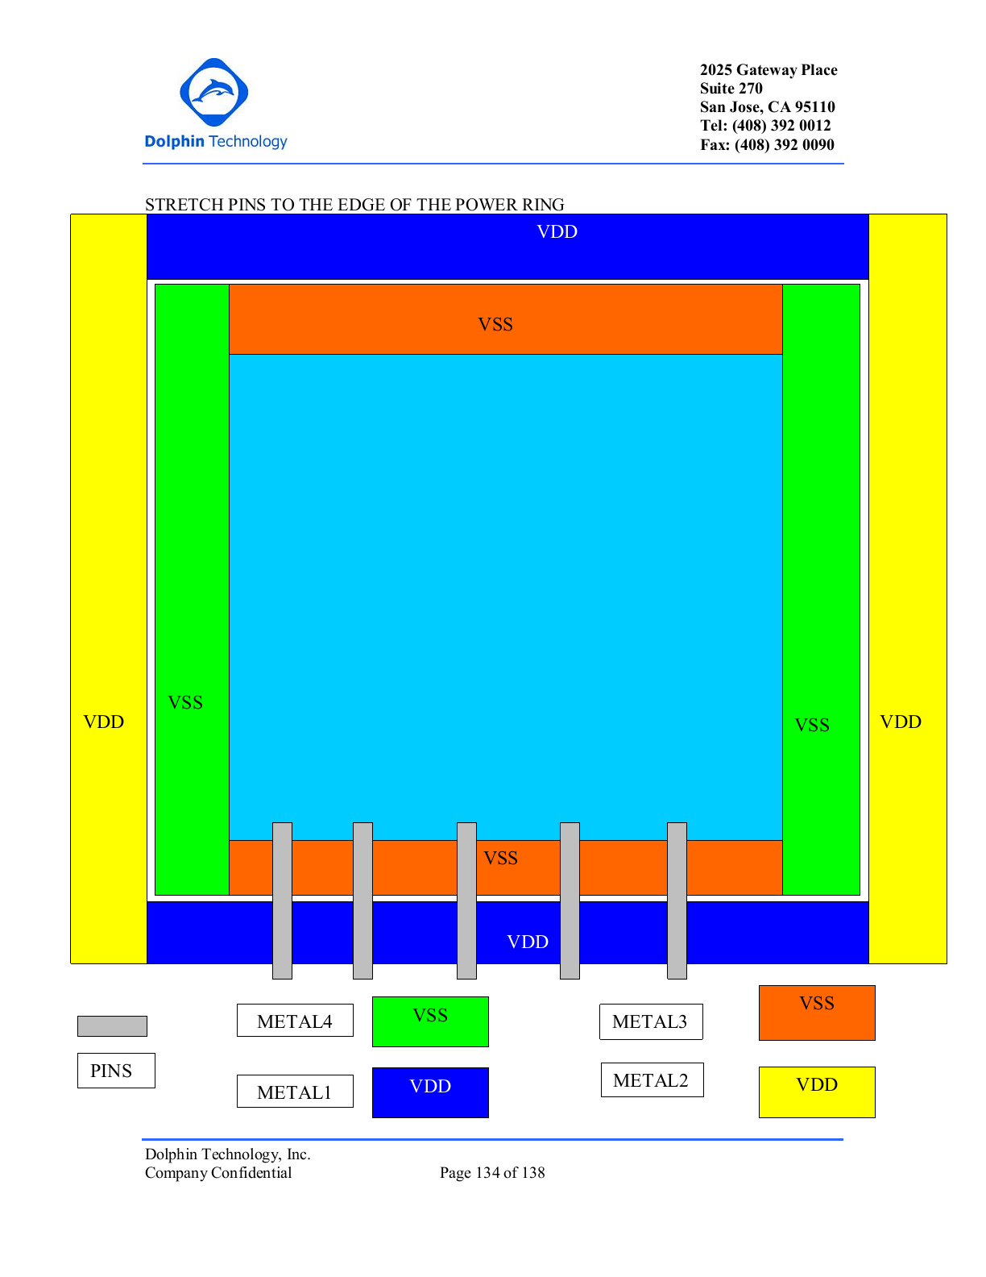

**OVERLAPPED POWER RINGS**

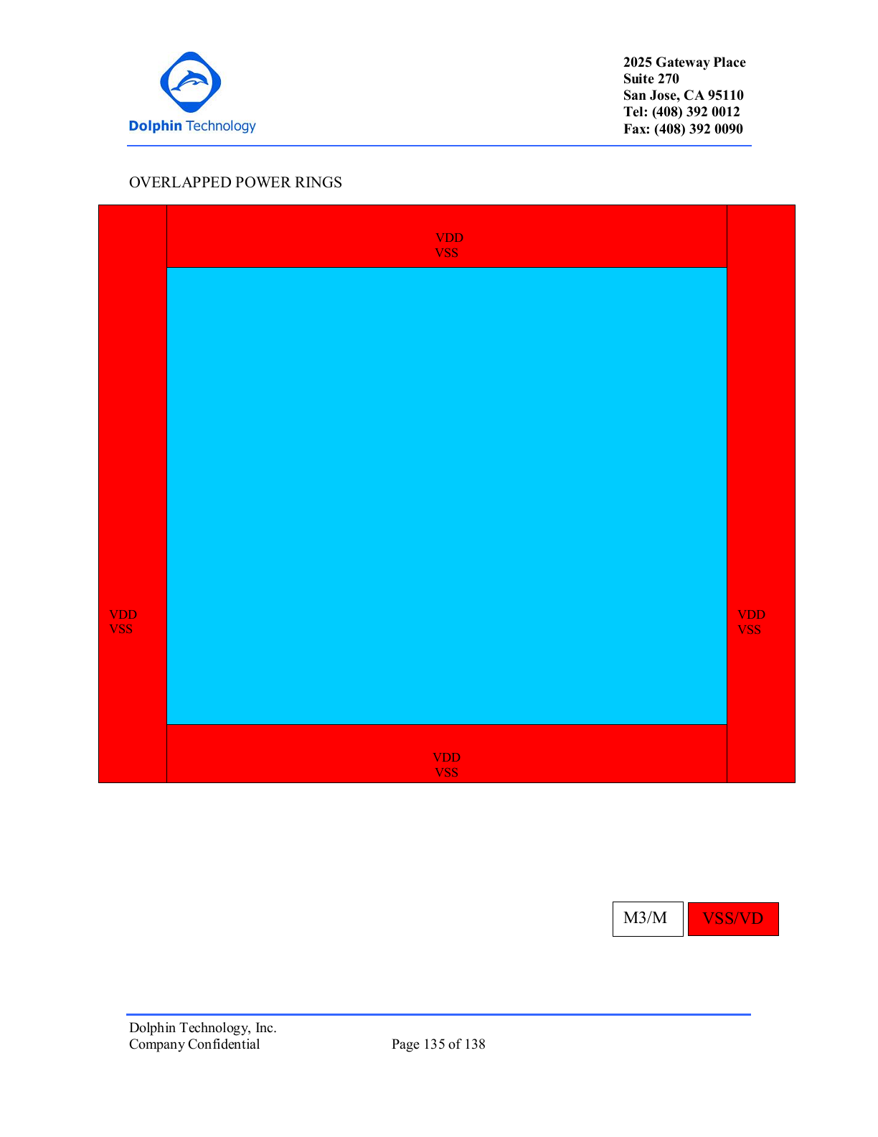

**NONOVERLAPPED POWER RINGS**

